**APPIUM-MOBILE-TESTING**

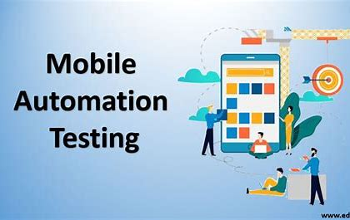

**Agenda:**

Content on building Appium Framework from the Zero using all latest technologies like TestNG, Maven, Page objects, Log4j, Extent Reports, cucumber, CI/CD Jenkins, Cloud Environment with Parallel execution.

**High Level Content:**

* Core Java Fundamentals for Automation.
* Appium Installation on Windows & Mac.
* Andrio Automation Testing with Appium on Virtual Devices & Real Devices.
* IOS Automation Testing with Appium on Virtual Devices & Real Devices.
* Hybrid Apps Automation with Appium. (Android + web = Hybrid apps)
* End to End Functional Mobile testing with all possible Testcases using Appium
* Mobile Browsers Automation with Appium
* Database Testing with Appium
* Appium Hybrid Framework Design from scratch
* Appium cloud Execution with Parallel Run Capabilities.

**Table of Contents:**

1. Introduction

1.1. Why Appium

1.2. Features

1.3. Architecture of Appium

1. Step by Step Instructions for Appium Configuration in Windows
2. Mobile Automation Android

3.1. UI Automator

3.2. Appium Inspector

3.3. Different Types Of locators.

1. Advanced Gestures Automation with Key Events Handling using Appium
2. Miscellaneous Activities like orientation & Key Events using Appium
3. End To End -ECommerce site: Native Apps
4. Hybrid Apps automation
5. Mobile Browser app automation
6. Implementation Of Framework
7. Android- Appium FrameWork

10.1. Maven Project Creation

10.2. Folder Structure of Maven Project

10.3. TestNg plugin Installation to eclipse

10.4. Dependency Injection To pom.xml

10.5. Structure Of framework- Package wise, Class wise

1. Global Configuration
2. Appium Server Configuration
3. Automation on Real Devices
4. Data Driven Testing

13.1. Excel Driven Testing

13.2. Json Driven Testing

1. Screen shot Capturing
2. Extent Report Generation

15.1. Listeners Implementation by implementing ITestListeners Interface.

15.2. Rerun the failed test case implementation

1. Allure Report
2. Log4j Implementation
3. Running Scripts through command line using maven commands
4. Jenkins setup

19.1. Free Style Project

19.2. Maven Project

1. GitHub Integration
2. Publishing Html Report
3. Publishing TestNg Results
4. SMTP Configuration
5. Sending email to configured email
6. Sending report attachment to email
7. Scheduling the job using build triggers.

**Introduction:**

**What is Appium**

Appium is open-Source Mobile Automation tool for testing native Apps (Android & IOS) and mobile browsers.

Appium Internally uses WebDriver Json wire (Which Selenium does) to test the Apps, so it is just like Selenium but for Mobile.

**Features Of Appium:**

* Appium is an open-source Mobile automation tool.
* The Only cross-platform test automation tool.
* Works for native, hybrid and mobile web apps

Native apps: When app is developed exclusively on mobile platforms -Android or IOS.

Hybrid apps: When app involves both mobile platform and web platform.

Web apps: When app involves only web platform.

* Supports Web driver API – Selenium Family!
* Supported Platforms

1. IOS
2. Android

**Code can be written in any language supported by WebDriver:**

Java, C#, JavaScript, Python, Ruby

**IDE: Eclipse**

**Appium Architecture:**

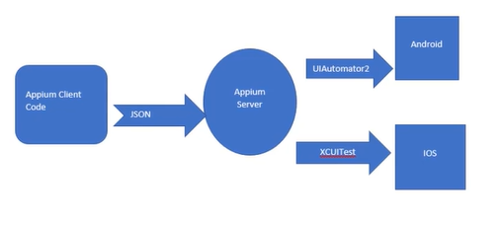

**Appium Client**: code we write to automate, Redirect the code to Appium server port where it is running.

-Code is converted into Json because server has ability to interpret the Json code.

**Appium Server**: we need to download and start the server in specific port – Server wait to receive the code from client.

-Server interpret the code and send to specific devices whether Android or IOS

**Android** has UIAutomator2 Framework to test android apps

**IOS** has XCUITest to test IOS apps

**Step by Step Instructions for Appium Configuration in Windows/ MAC**

* Download Java
* Download Android Studio and find out the Android SDK path
* Download Node
* Set (Java, Android SDK & Node) Home Paths in windows System variables
* Set (Java, Android SDK & Node) Home Paths in MAC OS System variables
* Open Android Studio and Configure Emulator/Virtual Device
* Install and start the Appium Server via Node
* Install Eclipse editor
* Setup Maven Project with Appium Client Dependencies
* Understand the Desired Capabilities to setup the Environment in the Appium
* Appium first program to invoke the Android Apps

**Java Download, Set Home Paths for Windows**

**Step 1:** <https://www.oracle.com/in/java/technologies/downloads/>

Download latest version of java for windows/ MAC

**Step 2:** Home path set up

C drive > program files> java > latest version >copy the path > env>environment variables – new button > JAVA_HOME – paste the path

C drive > program files> java > latest version> bin >env >environment Variables – path (select and click on edit)> new- paste the path

**Download Android Studio and find out the Android SDK path**

<https://developer.android.com/studio>

**Download Node**

<https://nodejs.org/en/download/prebuilt-installer>

**Set (Java, Android SDK & Node) Home Paths in windows System variables**

**Step 1:** C Drive > Users > Username > AppData > Local > Android > sdk

Set Environment variables

**Step 2:** Tools Folder to be displayed in sdk folder

* Launch Android Studio
* Create empty or basic activity project
* Open tools from nav bar
* Click on SDK Manger option under tools
* Click on SDK Tools
* Select Android SDK Tools
* Click Apply
* Click ok to install
* And Download

-Tools folder will be visible in sdk folder

**Step 3:** 1.C Drive > Users > Username > AppData > Local > Android > sdk > tools

2. C Drive > Users > Username > AppData > Local > Android > sdk > tools > bin

3. C Drive > Users > Username > AppData > Local > Android > sdk > platform-tools

Set system environment Path variables

**Step 4:** 1. C Drive > Program Files > Nodejs

2. C Drive > Program Files > Nodejs > node_modules > npm > bin

Set system environment Path variables

**Open Android Studio and Configure Emulator/Virtual Device**

**Step 1:** Launch android Studio and Create a project

**Step 2:** Go to tools in nav bar > Device Manger

**Step 3:** Click on Create Virtual Device

**Step 4:** Choose the pixel and click on next

**Step 5:** Choose the android version and click on next

**Step 6:** Give name to your virtual emulator.

**Step 7:** Now you can play your Virtual emulator

Virtual Emulator:

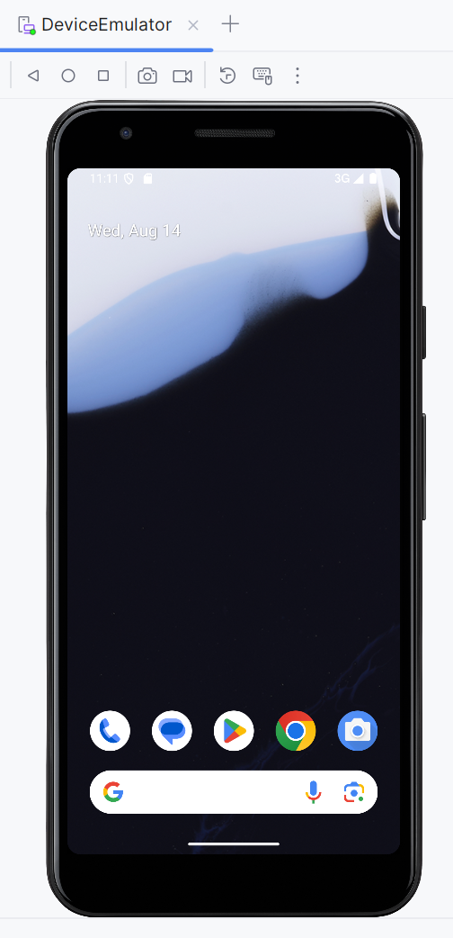

**Install and start the Appium Server via Node**

**Step 1:** Open cmd

**Step 2:** npm install -g appium (-g to install globally)

**Step 3:** To start Appium server

cmd > appium

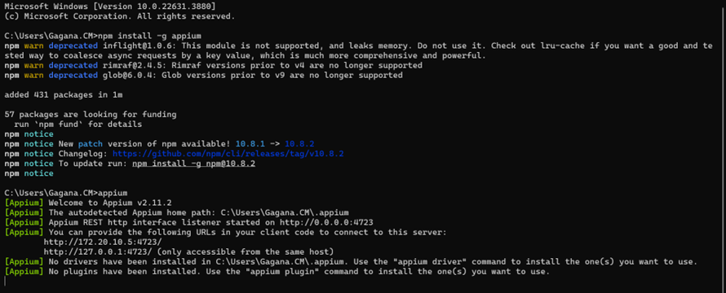

**Not able to start the Appium programmatically:**

1.CMD:

appium --allow-cors

2.Comment service.start()

**Install Eclipse:**

<https://www.eclipse.org/downloads/> -> Install latest Version



**Setup Maven Project with Appium Client Dependencies**

**Step 1:** Open Eclispe

**Step 2:** Click on New > Maven Project > Click on Next

**Step 3:** Select Archetype -maven-archetype-quickstart

**Step 4:** Give Group id and ArtifactId >Click on next > Maven project is created

**Step 5:** Dependencies > go to maven central repository

1.Appium > Java Client

2. Framework: TestNG

Paste it in pom.xml

**Install TestNg Plugin**

**Step 1:** Go to help on Eclipse nav bar

**Step 2:** Click on Eclipse MarketPlace

**Step 3:** Search for TestNg

**Step 4:** Install TestNg for eclipse plugin

Note: If java version is 8 and below use testNg version from 6 and below.

If Java version is greater than or equal to 11 then testNg should be latest.

**Mobile Automation Android**

**UIAutomator**

**What is UIAutomator and creating UiAutomator object to define Capabilities**

UIAutomator is a UI testing framework introduced by google to facilitate automation on a Android device or emulator.

Appium leverage this UIAutomator with its own wrapper and came up with UIAutomator2 Driver to automate the Android Apps

**To install appium UIAutomator**

Step 1: Open cmd : appium driver list

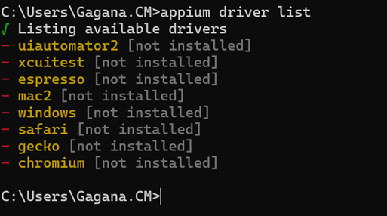

Step 2: To install : appium driver install uiautomator2

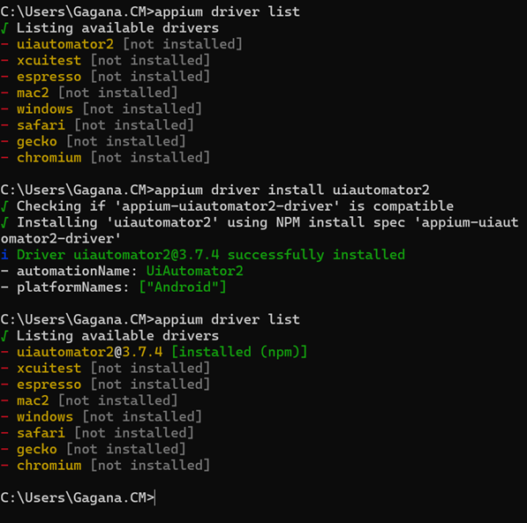

**First Program:**

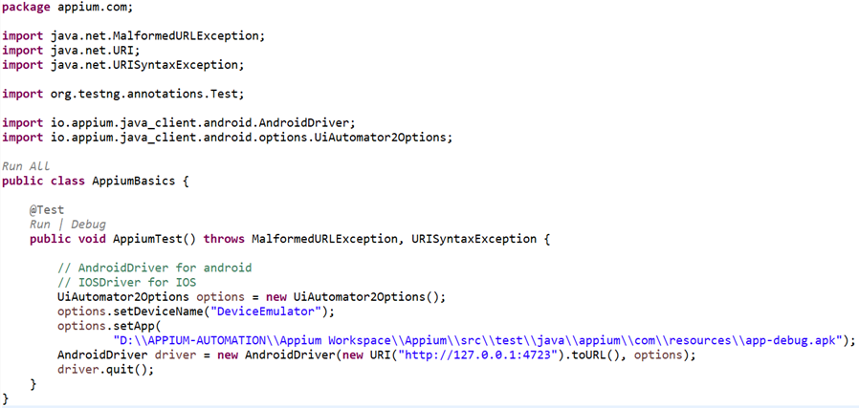

**How to start & Stop Appium Server Programmatically using AppiumServiceBuilder**

C Drive > user > username > AppData > Roaming > npm > node_modules > appium > build > lib > main.js

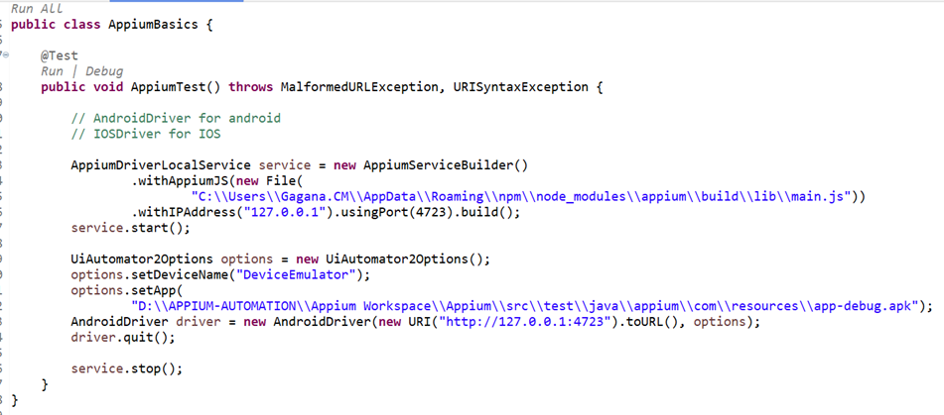

**Introduction to Appium Inspector to identify the elements on the Apps**

Locators Appium supports:

* Xpath
* Id
* accessibilityId
* className
* androidUIAutomator

**Appium Inspector**

<https://github.com/appium/appium-inspector/releases>

Step 1: Download appium inspector .exe file for windows and install

Step 2: Open Appium inspector

Step 3 :Do Configuration in Appium Inspector

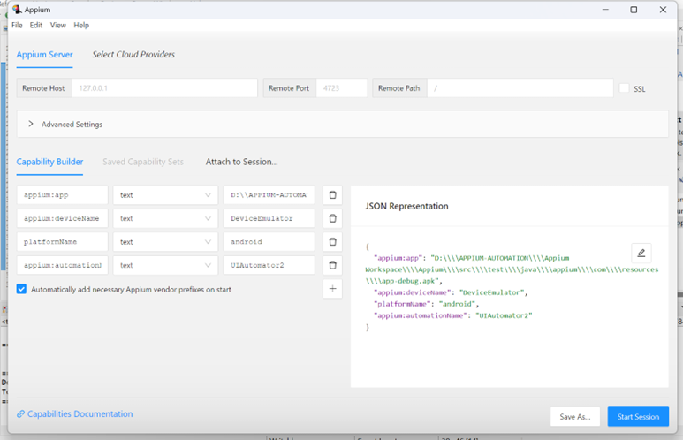

Step 4: Click on start session

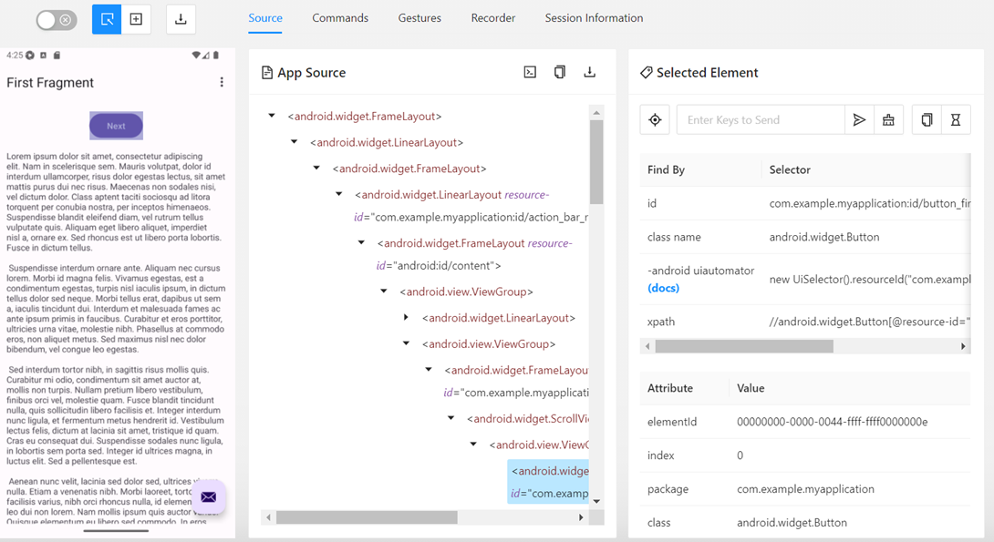

For that particular next button we we get Selectors

Use that to proceed

driver.findElement(AppiumBy.*xpath*("//android.widget.Button[@resource-id=\"com.example.myapplication:id/button_first\"]")).click();

**Different Locators:**

driver.findElement(By.*xpath*(“ ”)) click();

driver.findElement(By.*Id*(“ “)).click();

driver.findElement(AppiumBy.*accessibilityId* (" ")).click();

driver.findElement(AppiumBy.className (" ")).click();

**Advanced Gestures Automation with Key Events Handling using Appium**

Documentation about Gestures:

<https://github.com/appium/appium-uiautomator2-driver/blob/master/docs/android-mobile-gestures.md>

1. **mobile: Long Click:**

((JavascriptExecutor) driver).executeScript("mobile: longClickGesture", ImmutableMap.of(

"elementId", ((RemoteWebElement) element).getId()

));

**Or**

driver.execute_script('mobile: longClickGesture', {'x': 100, 'y': 100, 'duration': 1000})

**Example:**

WebElement ele = driver.findElement(By.*xpath*("//android.widget.TextView[@text='People Names']"));

((JavascriptExecutor) driver).executeScript("mobile: longClickGesture",

ImmutableMap.*of*("elementId", ((RemoteWebElement) ele).getId(), "duration", 2000));

1. **mobile :Double Click:**

((JavascriptExecutor) driver).executeScript("mobile: doubleClickGesture", ImmutableMap.of(

"elementId", ((RemoteWebElement) element).getId()

));

1. **mobile: clickGesture**

driver.executeScript("mobile: clickGesture", ImmutableMap.of(

"elementId", ((RemoteWebElement) element).getId()

));

1. **mobile: dragGesture**

((JavascriptExecutor) driver).executeScript("mobile: dragGesture", ImmutableMap.of(

"elementId", ((RemoteWebElement) element).getId(),

"endX", 100,

"endY", 100

));

1. **mobile: flingGesture**

boolean canScrollMore = (Boolean) ((JavascriptExecutor) driver).executeScript("mobile: flingGesture", ImmutableMap.of(

"elementId", ((RemoteWebElement) element).getId(),

"direction", "down",

"speed", 500

));

1. **mobile: pinchOpenGesture**

((JavascriptExecutor) driver).executeScript("mobile: pinchOpenGesture", ImmutableMap.of(

"elementId", ((RemoteWebElement) element).getId(),

"percent", 0.75

));

1. **mobile: pinchCloseGesture**

((JavascriptExecutor) driver).executeScript("mobile: pinchCloseGesture", ImmutableMap.of(

"elementId", ((RemoteWebElement) element).getId(),

"percent", 0.75

));

1. **mobile: swipeGesture**

((JavascriptExecutor) driver).executeScript("mobile: swipeGesture", ImmutableMap.of(

"left", 100, "top", 100, "width", 200, "height", 200,

"direction", "left",

"percent", 0.75

));

1. **mobile: scrollGesture**

boolean canScrollMore = (Boolean) ((JavascriptExecutor) driver).executeScript("mobile: scrollGesture", ImmutableMap.of(

"left", 100, "top", 100, "width", 200, "height", 200,

"direction", "down",

"percent", 1.0

));

**Or: Where to scroll is know Prior**

driver.findElement(AppiumBy.*androidUIAutomator*("new UiScrollable(new UiSelector()).scrollIntoView(text(\"WebView\"))"));

**Or : When want to scroll to end**

**boolean** canScrollMore;

**do** {

canScrollMore = (Boolean) ((JavascriptExecutor) driver).executeScript("mobile: scrollGesture", ImmutableMap

.*of*("left", 100, "top", 100, "width", 200, "height", 200, "direction", "down", "percent", 1.0));

} **while** (canScrollMore);

**Miscellaneous Activities like orientation & KeyEvents using Appium**

1. **To Run the Script in Land Scape mode -Rotation**

DeviceRotation landScape = **new** DeviceRotation(0, 0, 90);

driver.rotate(landScape);

After Execution set it back into portrait mode only:

DeviceRotation portrait= **new** DeviceRotation(0, 0, 0);

driver.rotate(portrait);

1. **Copy to Clipboard and paste it**

driver.setClipboardText("GaganaWifi");

driver.findElement(By.*id*("android:id/edit")).sendKeys(driver.getClipboardText());

1. **Pressing back button, Home button , pressing enter in keyboard**

driver.pressKey(new KeyEvent(AndroidKey.*ENTER*));

driver.pressKey(new KeyEvent(AndroidKey.*BACK*));

driver.pressKey(new KeyEvent(AndroidKey.*HOME*));

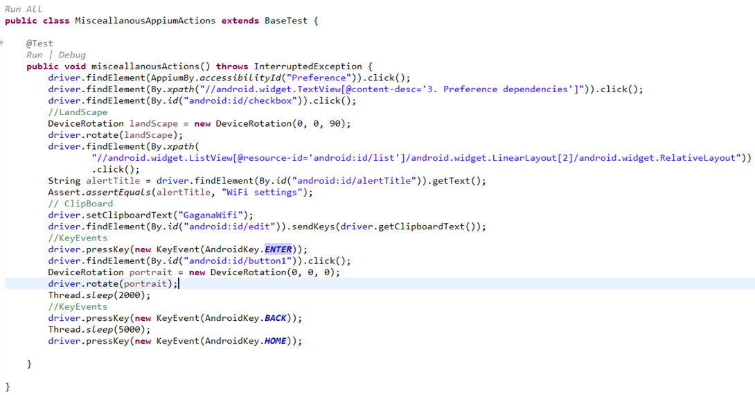

**Open App Using Package and Activity Name**

In Order fetch App Package name and Activity name:

**Step 1:** Open Cmd prompt

**Step 2:** Search for the devices running (Note :Device should be running)

**Step 3:** give cmd : **adb devices**

**Step 4:** Search for App package and Activity name : cmd -> **adb shell dumpsys window | findstr "mCurrentFocus"** 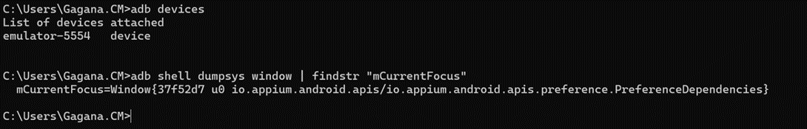mCurrentFocus=Window{37f52d7 u0 io.appium.android.apis/io.appium.android.apis.preference.PreferenceDependencies}

Note :Before Slash is Package name ,After Slash is Activity Name

**PackageName**: io.appium.android.apis

**Activity Name**: io.appium.android.apis.preference.PreferenceDependencies

**Syntax to use :**

Activity activity = new Activity("io.appium.android.apis","io.appium.android.apis.preference.PreferenceDependencies");

driver.startActivity(activity);

**Or**

((JavascriptExecutor) driver).executeScript("mobile: startActivity", ImmutableMap.*of*("intent",

"io.appium.android.apis/io.appium.android.apis.preference.PreferenceDependencies"));

**End To End -Ecommerce site: Native Apps**

**Test Scenarios to Automate**

1.Fill the form details and verify Toast error message displayed appropriately for wrong inputs.

2.Shop the items in the app by scrolling to specific product and add to cart.

3.Validate if the items selected in the page 2 are matching with items displayed in check out page.

4.Validate the total amount displayed in the checkout page matches with sum of product amounts selected for shopping.

5.Validate Mobile gestures working for links (long press) and navigate to webview.

6.Verify if user can do operations on web view and can navigate back to native app if needed

Note: open cmd

adb install D:\APPIUM-AUTOMATION\General-Store.apk

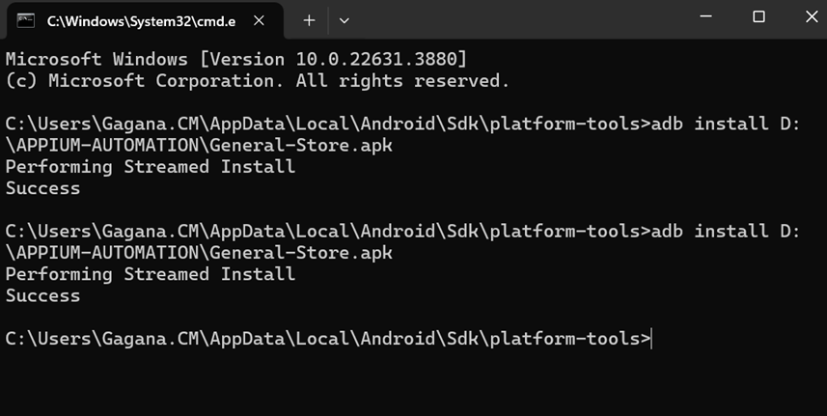

1. **To hide KeyBoard:**

driver.hideKeyboard();

1. **To Handle Toast messages:**

Usually it will have tag name as **android.widget.Toast**

Toast messages will be present in name attribute

String toastMessage = driver.findElement(By.*xpath*("(//android.widget.Toast)[1]")).getAttribute("name");

Assert.*assertEquals*(toastMessage, "Please enter your name");

1. **Synchronization: Wait Mechanism**

Dependency : Selenium support

WebDriverWait wait = **new** WebDriverWait(driver, Duration.*ofSeconds*(5));

wait.until(ExpectedConditions.*attributeContains*(driver.findElement(By.*id*("com.androidsample.generalstore:id/toolbar_title")), "text", "Cart"));

**Hybrid Apps Automation**

**Step 1:To Switch the context**

Set<String> contexts = driver.getContextHandles();

for (String context : contexts) {

System.*out*.println(context);

}

driver.context("WEBVIEW_com.androidsample.generalstore");

// After switching it is similar work like a selenium

driver.findElement(By.*name*("q")).sendKeys("Valtech");

driver.findElement(By.*name*("q")).sendKeys(Keys.*ENTER*);

driver.pressKey(new KeyEvent(AndroidKey.*BACK*));

driver.context("NATIVE_APP");

**Step 2: After Need to set chromedriver to UiAutomator2Options:**

Download ChromeDriver which is compatible with your chrome version and set options.

UiAutomator2Options options = **new** UiAutomator2Options();

options.setDeviceName("DeviceEmulator");

options.setChromedriverExecutable("D:\\APPIUM-AUTOMATION\\chromedriver-win64\\chromedriver.exe");

**Or if not works:**

Add WebManager dependency to pom.xml

<dependency>

<groupId>io.github.bonigarcia</groupId>

<artifactId>webdrivermanager</artifactId>

<version>5.3.2</version>

</dependency>

**In Base Test:**

WebDriverManager.*chromedriver*().setup();

UiAutomator2Options options = **new** UiAutomator2Options();

options.setDeviceName("DeviceEmulator");

options.setChromedriverExecutable(WebDriverManager.*chromedriver*().getDownloadedDriverPath());

**Mobile Chrome Browsers Automation:**

1. **Need to set chromedriver to UiAutomator2Options:**

Download ChromeDriver which is compatible with your chrome version and set options.

UiAutomator2Options options = **new** UiAutomator2Options();

options.setDeviceName("DeviceEmulator");

options.setChromedriverExecutable("D:\\APPIUM-AUTOMATION\\chromedriver-win64\\chromedriver.exe");

1. **Scroll and put assertions on Browser Tests**

((JavascriptExecutor) driver).executeScript("window.scrollBy(0,1000)", "");

**Framework:**

* Understand the importance of framework development
* Build page Object Factory pattern to drive the Element locators to the tests
* Implement Android Page object repositories for the respective Platform tests
* Build Actions utility classes for both Android apps to store reusable Mobile Gestures
* Implement Base Test with capabilities where all Tests inherit it into their respective classes
* Methods to dynamically Start & Stop Appium server before every test
* Build Test Strategy on how tests should be written in isolation with setup & Teardown methods
* Create Properties file to implement Global configuration values into the Framework
* Build TestNg.xml files to run all tests together with proper class, suite, test conventions inside the xml file
* Introduce Extent Reports to get excellent HTML reports of Framework results
* Introduce Allure Report to get excellent graphical report
* Implement TestNG listeners to capture screenshots on test failures & report it back to Extent Reports
* Data Driven testing from Json payloads into test using Jackson Mapper & TestNG Data provider
* Data Driven testing to fetch data from Excel file
* Implement set of Maven Profiles using TestNG.xml runner files to run tests with Maven commands.
* Jenkins set up Maven, Free Style and to build periodically

**Mobile Android Appium Framework**

**How to create a Maven Project for Appium mobile Automation Framework?**

* **Step 1:** create Maven project from File menu. File -> Maven project -> Choose the folder where the framework needs to be configured (Select the folder which was created earlier)

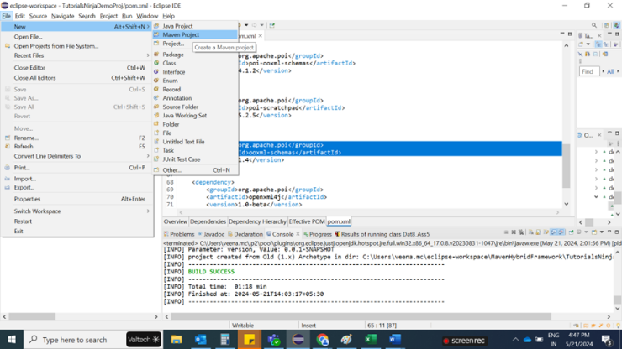

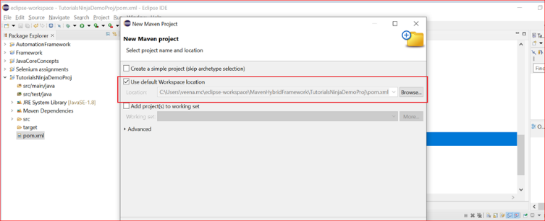

* **Step 2 :** Next select org.apache.maven.archetypes maven-archetypes-quickstart option

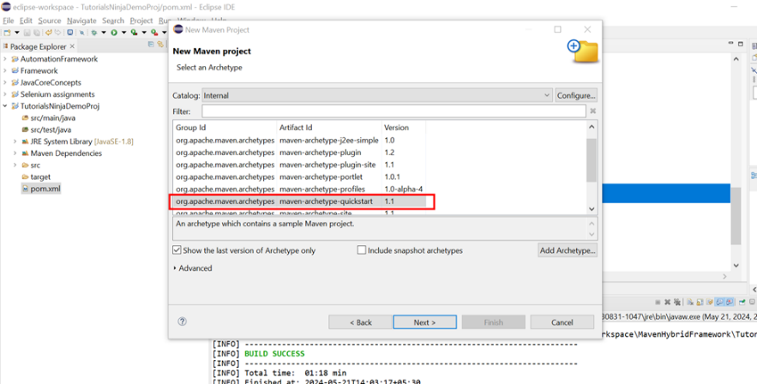

* **Step 3:** Then in the New Maven project window, enter unique Group Id, enter project name in Artifact Id and click on Finish button.

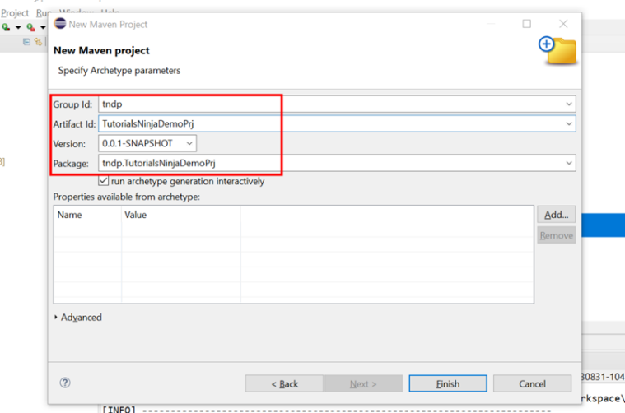

* **Step 4:** Maven Project structure is created as shown below.

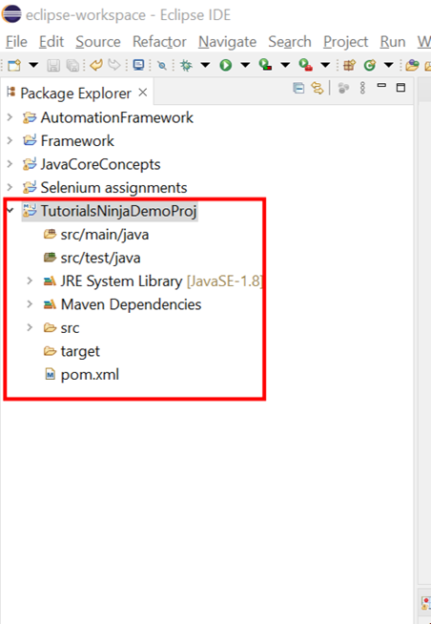

* **Step 5:** Install the testNG plugin from the Eclipse Marketplace. Help> Eclipse Marketplace> search for testNG plugin.
* Once testNG is installation is done, go to POM xml file and add needed dependencies.
* Regarding Dependencies, you can get it from Mavenrepository website . https://mvnrepository.com/
* TestNG, Java-client and Selenium Support.

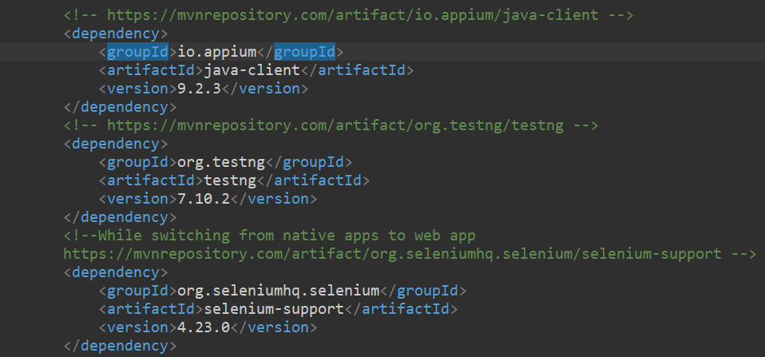

* Here is the folder structure for our framework.

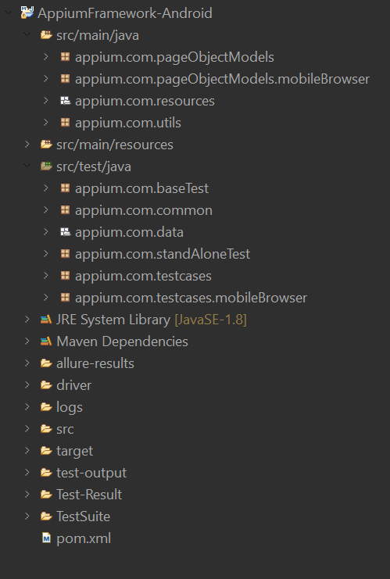

* Here we have different folder structures.
* Let’s Start with src/main/java, inside that we are creating one package for page Object Models for Native and hybrid apps.
* Inside that we are creating different classes for each Pages.

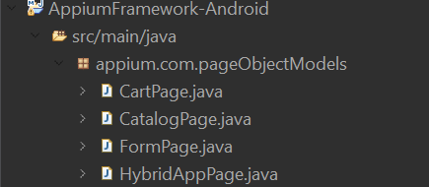

* Next, we create another Package for Mobile Browser page object Models
* Inside that create a different class for each page.

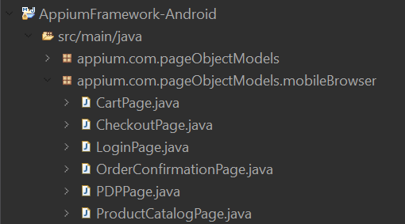

* Next, we create another Package called resources.
* Inside that create a file as Global.properties for global configuration.

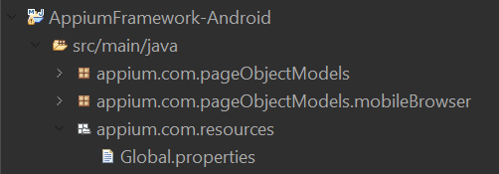

* Next, we create another Package called utils
* Inside that create a class which is common class for page object models

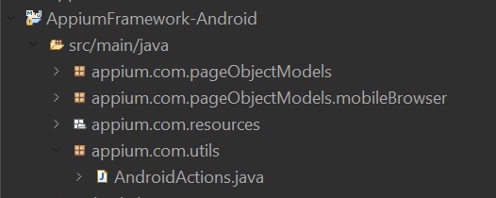

* And for src/test/java folder we create a package that is nothing but baseTest.
* Inside that create class for MobileBrowser and Native app acts as base test

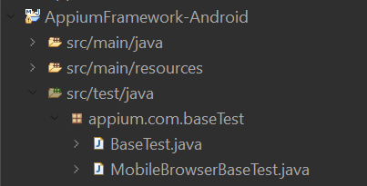

* Create One more package as common
* Inside that create classes which is common across all the test cases.

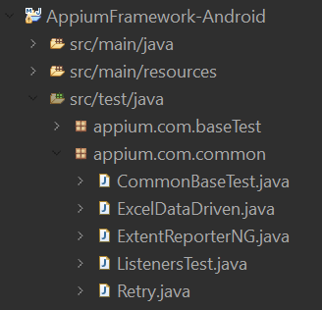

* Create One more package data
* Inside that create a place all data files.

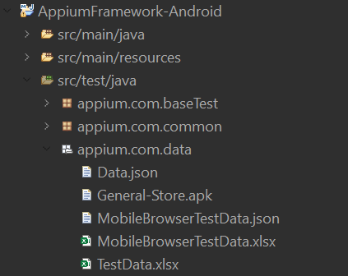

* Create one more package Standalone
* Inside that place single flow of test cases

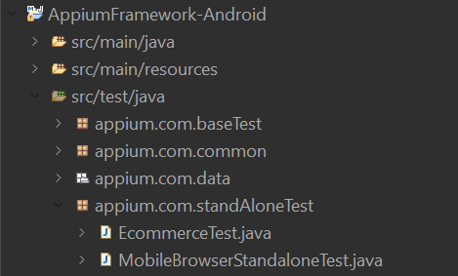

* Create One more package test cases-Native app/Hybrid app
* Place all the test cases related to native/hybrid app

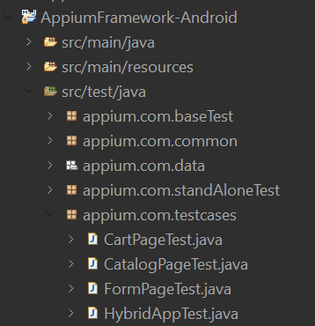

* Create one more package mobile Browser testcases.
* Inside that place all the test cases related to mobile browser automation.

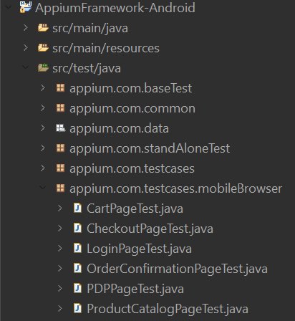

**Global Configuration**

Inside Global.properties file place all global configuration details.

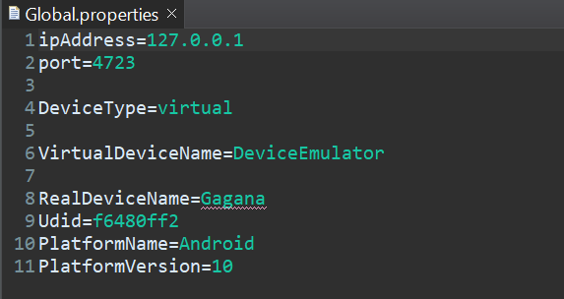

**Appium Server Configuration.**

In common Base test class place appium server starting code ,UIAutomator initialization, Driver initialization.

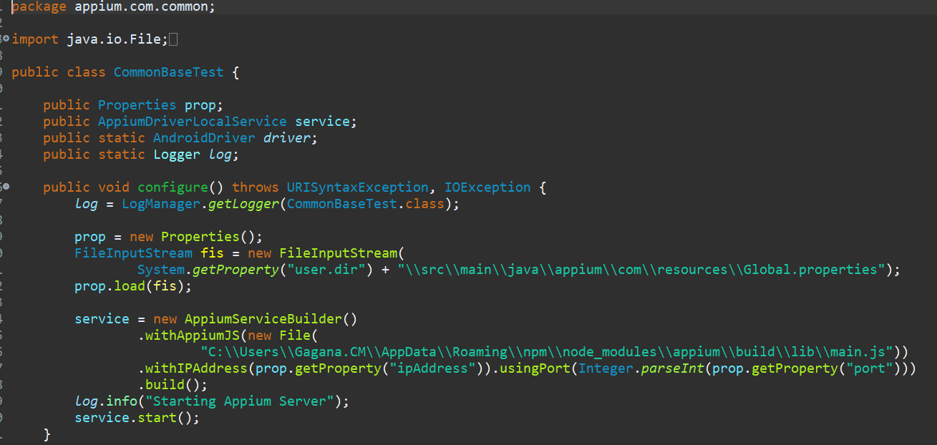

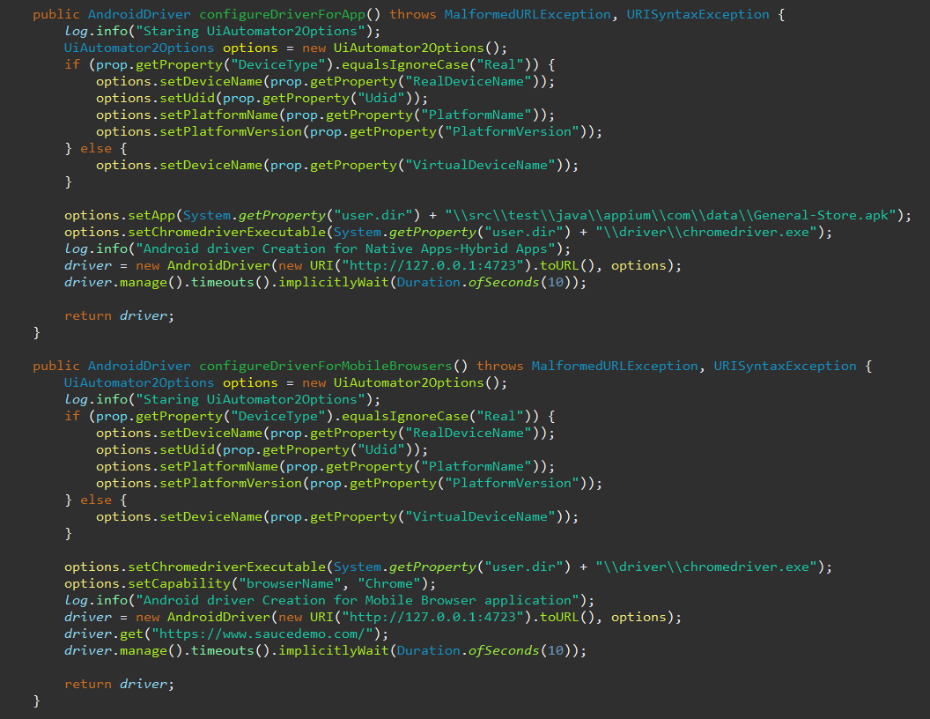

**Real Device Automation**

* On Your Real Device Go to About Phone
* Click on Version Until you are developer

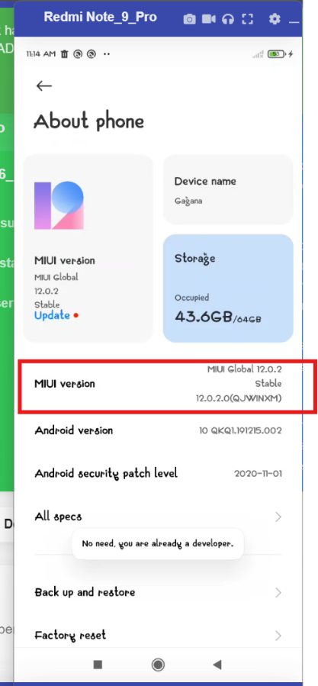

* Once You're a developer, Developer option click on it and find for USB Debugging option and enable it.

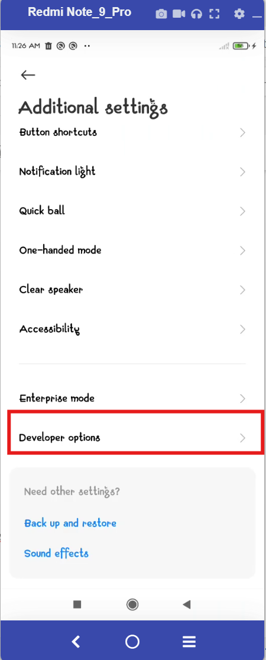

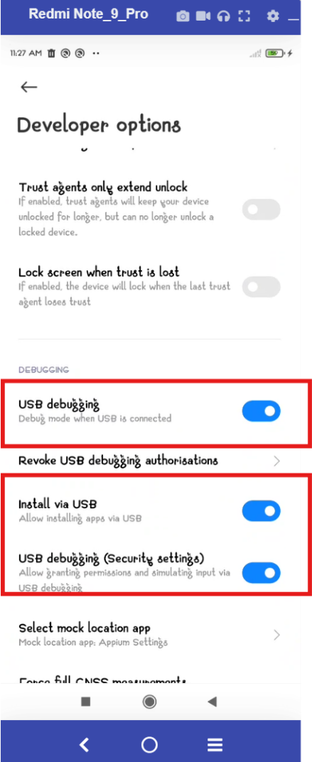

* Enable all the options as showed above.
* Now Connect Your device to laptop
* Install a Vysor Tool from official site. [**https://www.vysor.io/download/**](https://www.vysor.io/download/)
* After Installing Open Vysor and see the device connected.

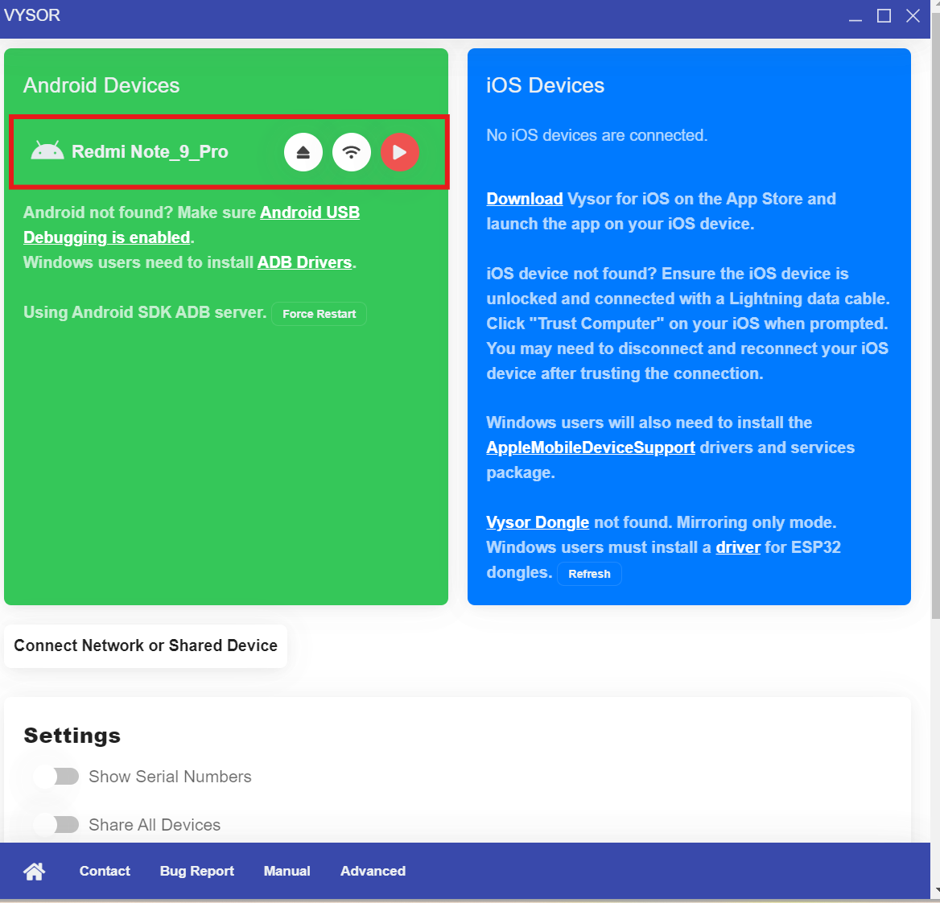

* Click on The Device, Now you can see your device and can operate on it
* Now Write Scripts to Automate on Your Device
* For that you need your Device information like,

1. Device Name
2. Udid
3. Android Version
4. PlatformName
5. PlatformVersion

Udid u can obtain as below by running command on cmd prompt

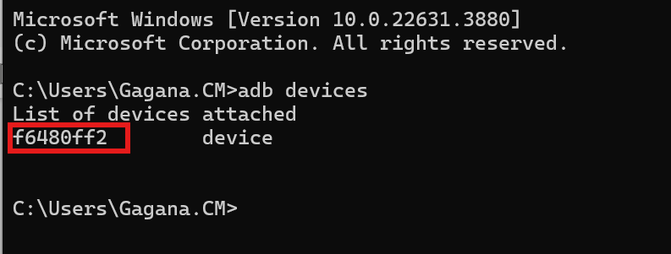

Left all other information you will obtain on your real device.

Example: To open calculator on Real Device:

Install app.info application on your device, So that you can obtain package and activity name of the applications which is present on your device.

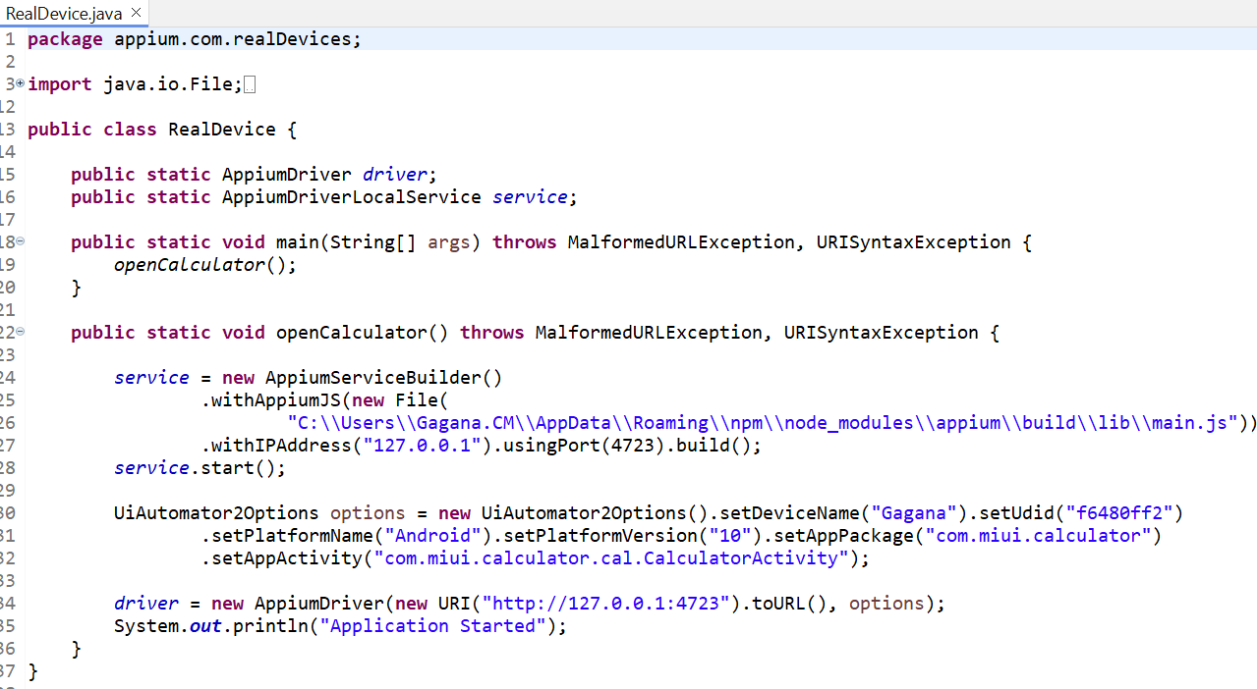

Similarly, you can use in your framework code.

In case of Appium Inspector you should follow above steps but in appium inspector you should give as below.

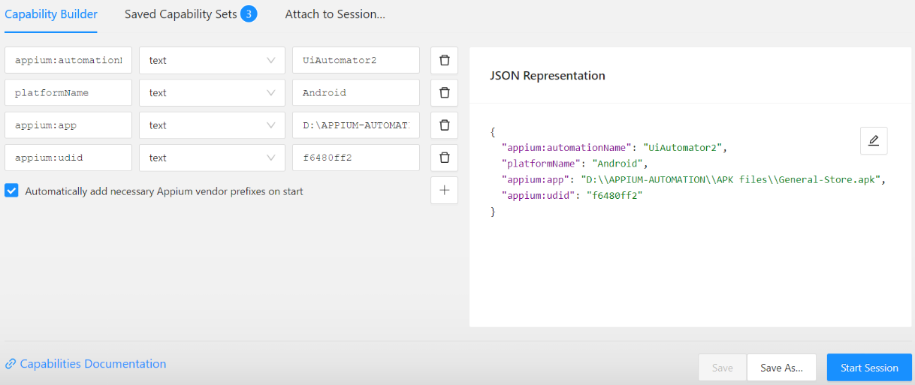

**Data Driven Testing**

**Excel Data Driven:**

Reading Data from Excel file and storing it in Hash Map in key value pair.

Place the excel files under package data



To access data from excel add required dependencies to pom.xml

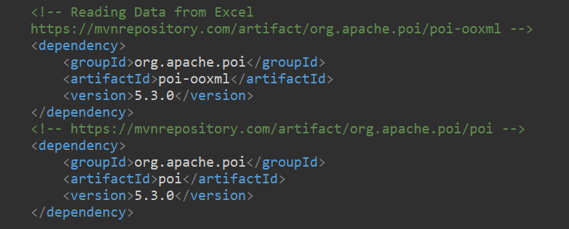

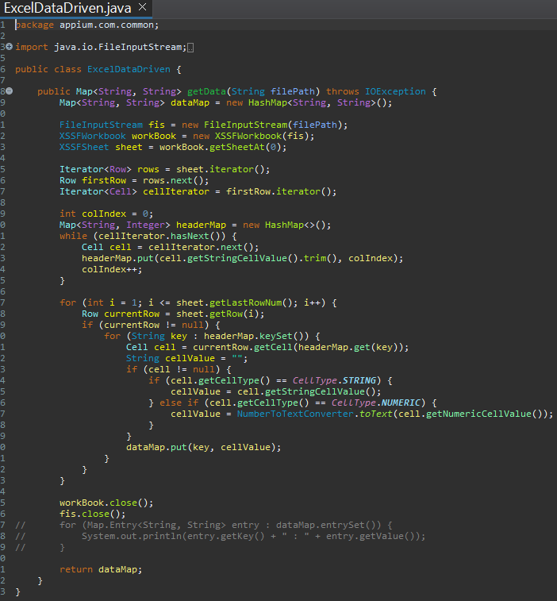

Using stored data to on test cases.

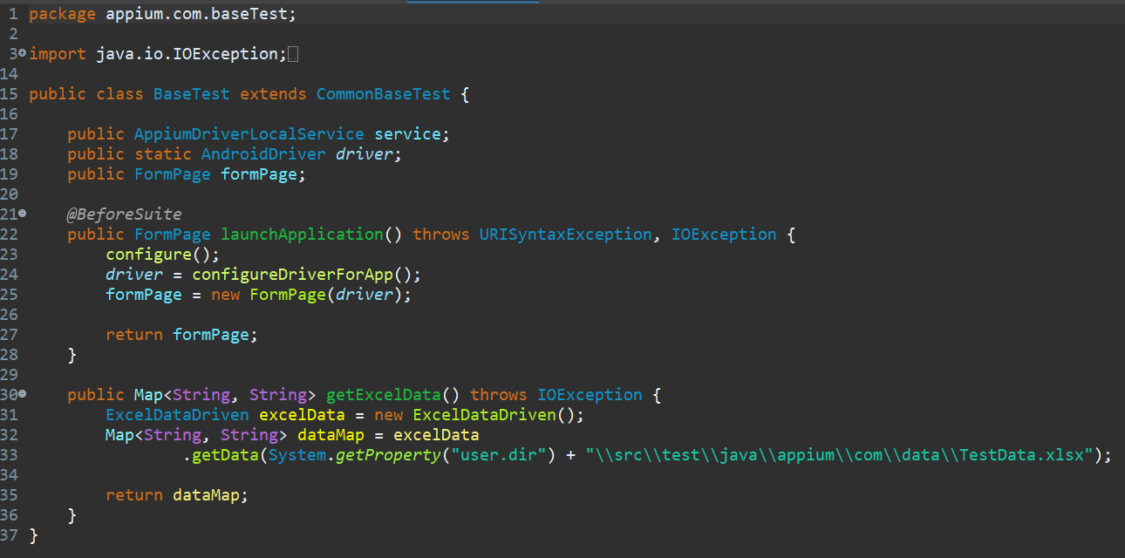

**Json Data Driven**

Reading Data from Json file and passing data with the help of Data provider annotation.

Place Json files under data package.



To access data from Json file, add required dependencies to pom.xml

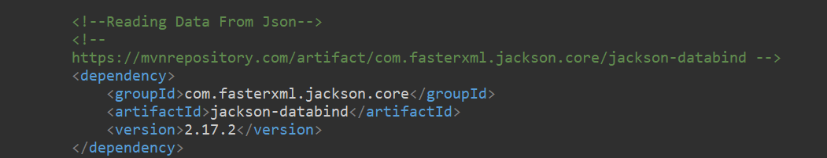

To Read Data from JSON

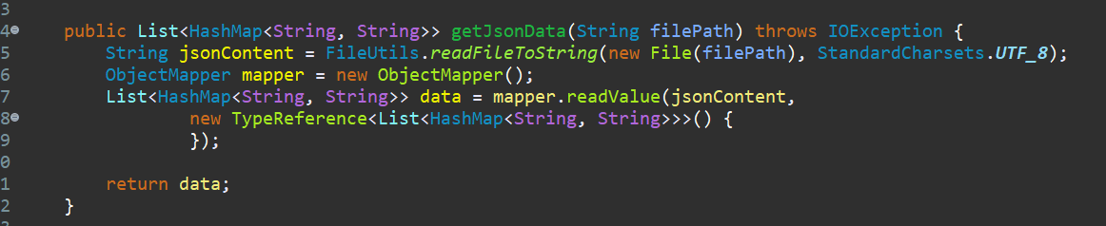

Using stored data to on test cases with help of Data Provider annotation

@DataProvider -> Single test case can be run multiple times by providing multiple data sets.

**JSON file**

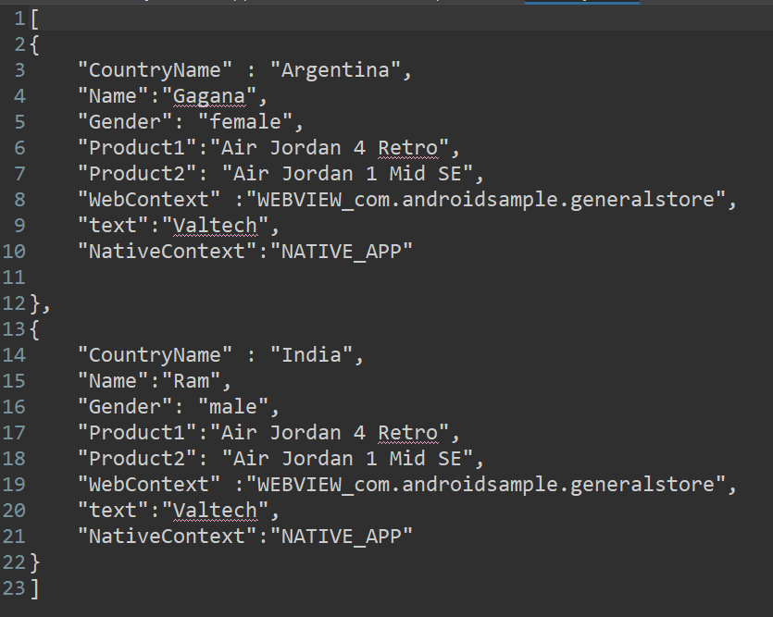

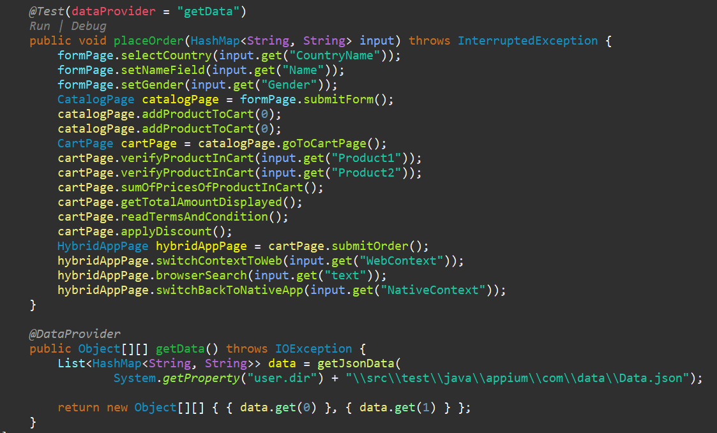

**Screenshot Capturing and storing it framework**

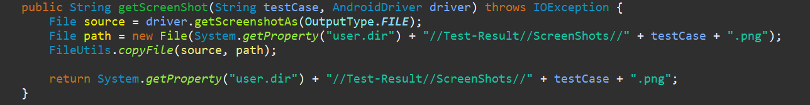

**Extent Report Generation**

Add Dependency which is required to generate extent report in pom.xml

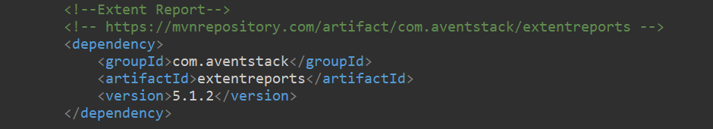

Extent Report Generation.

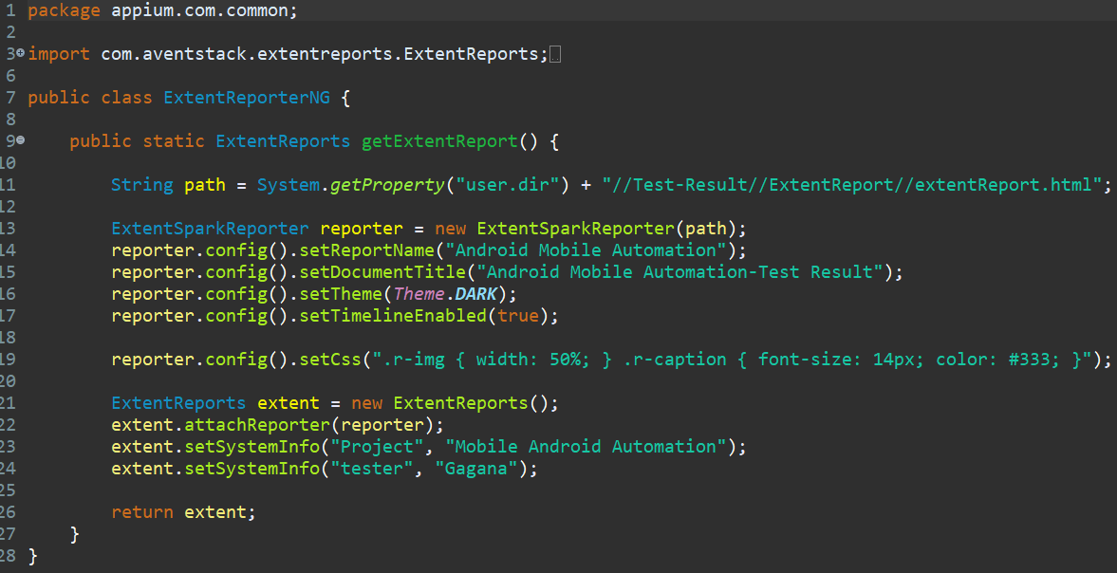

**Listeners Implemenation**

To Generate report

To attach Screen shot to report

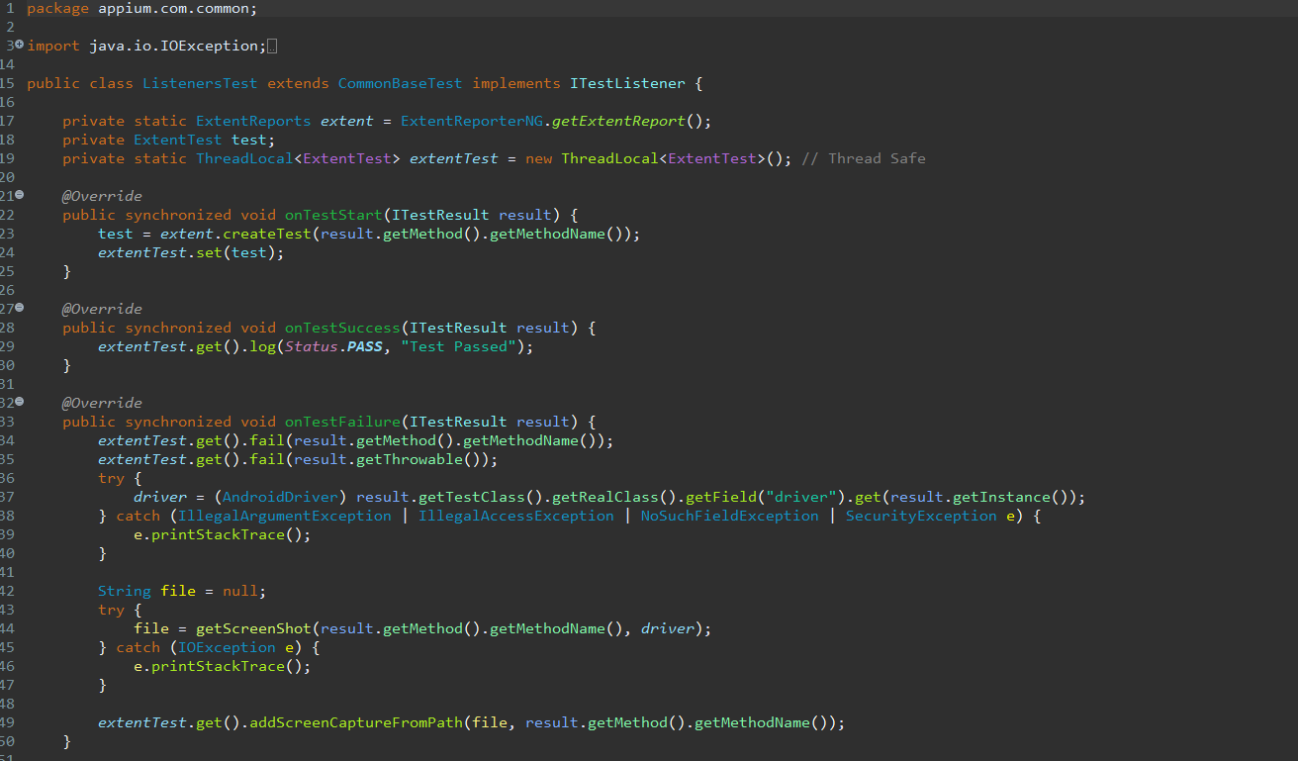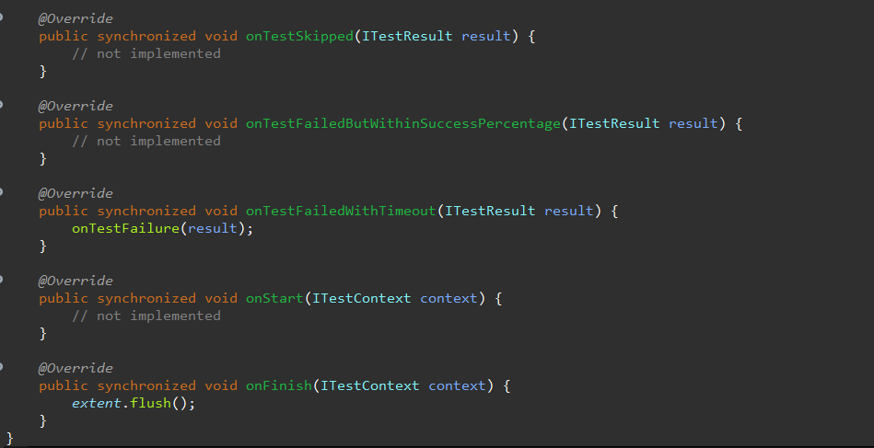

Rerun the failed test cases

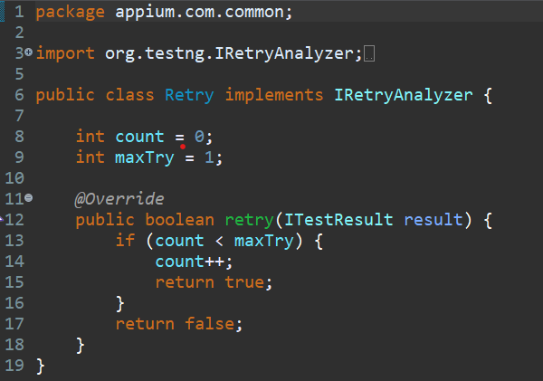

Using Retry.class on Test cases

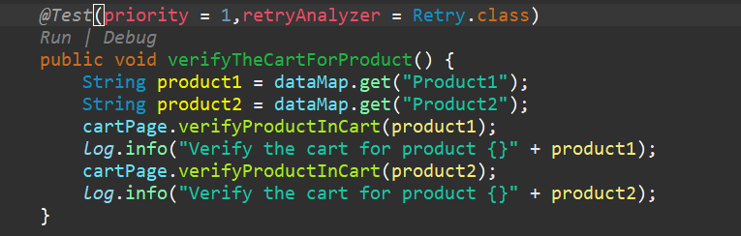

Report Screen Shot:

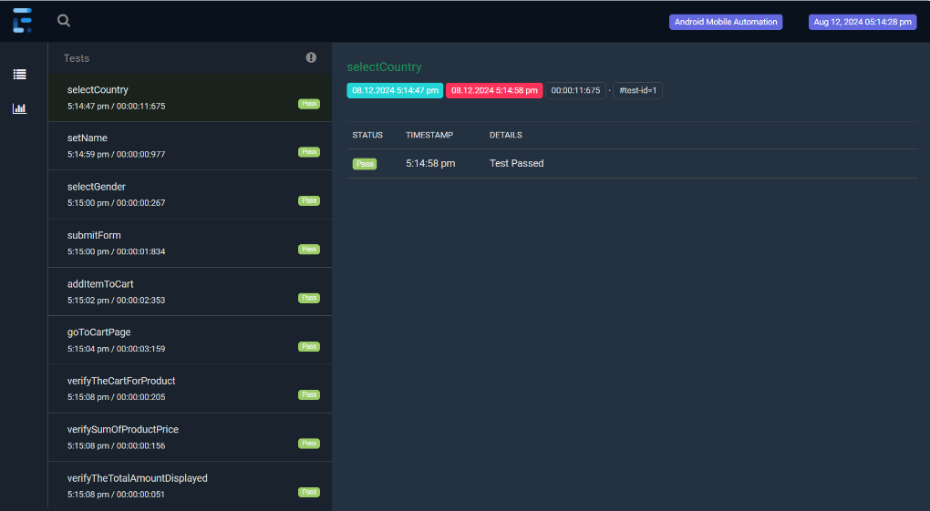

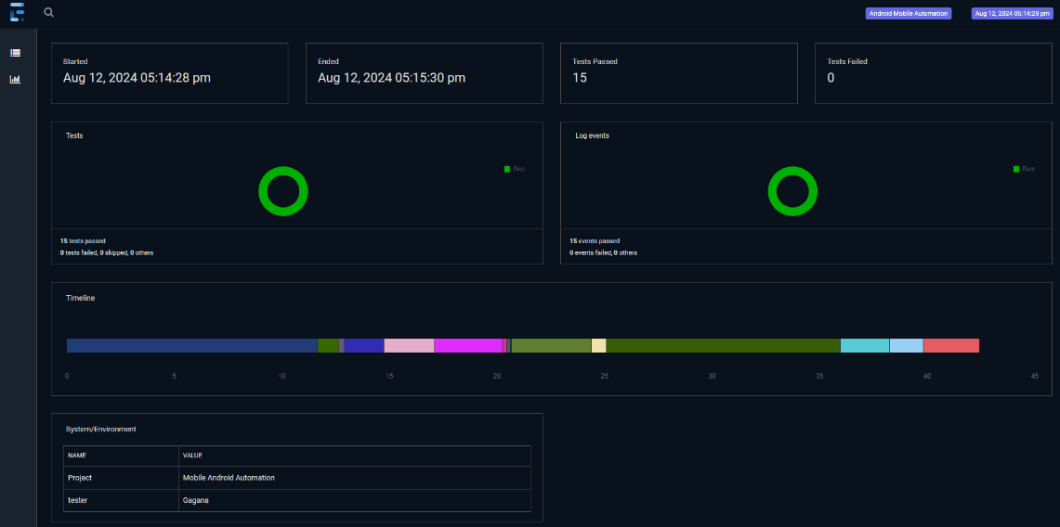

**Report Will Be Generated in Framework Project Structure while storing Screenshots:**

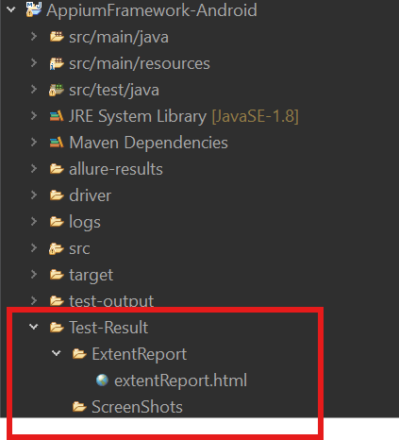

**Allure Report Generation**

Allure Report is a flexible multi-language test report to show you a detailed representation of what has been tested and extract maximum of useful information from everyday execution pf tests.

1. **Maven Dependency**

Allure-TestNG

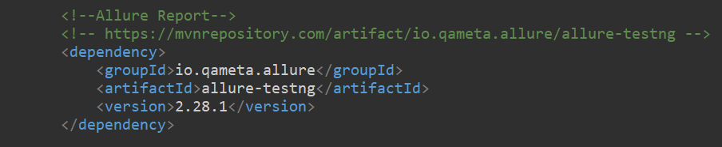

1. **Download Allure binaries(Zip) and set the path :**

<https://github.com/allure-framework/allure2/releases>

**Alternatively, allure can also be installed from Powershell using below commands,**

Iex(new-object net.webclient).downloadstring(‘https://get.scoop.sh’)

Scoop install allure

1. **Run Tests using below commands(Ensure maven is installed in your system)**

mvn clean test

1. **Now Let us run below command to generate allure reports**

allure serve

**Note:**

* Run the test case
* Refresh the project
* Open Cmd upto pom.xml of Project
* Run commad – allure serve

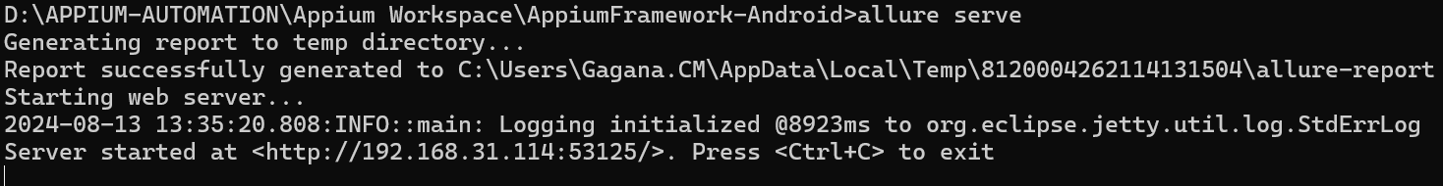

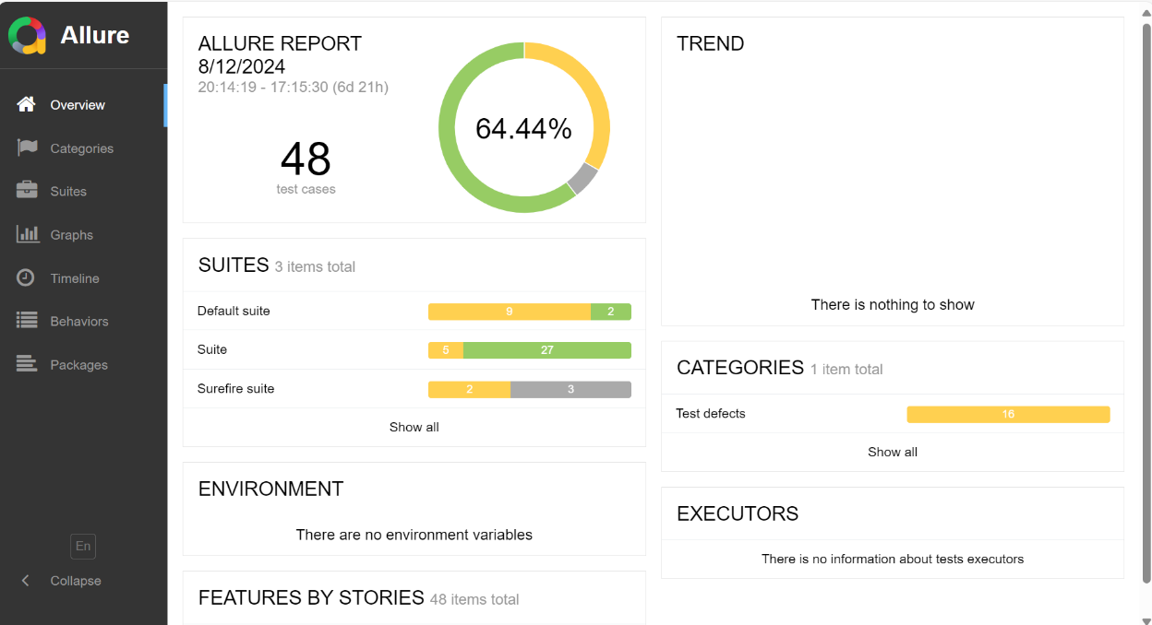

**Log4J Implementation**

Add Required Dependencies

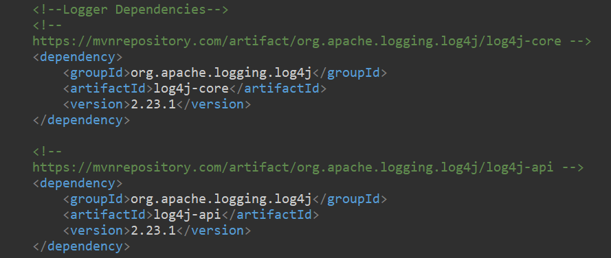

1.Through xml File:

2. Through Properties File:

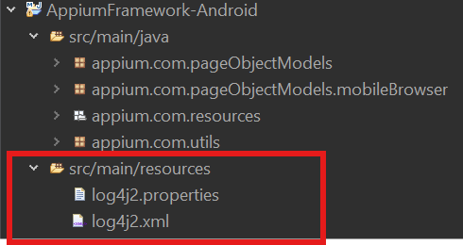

**Xml File**

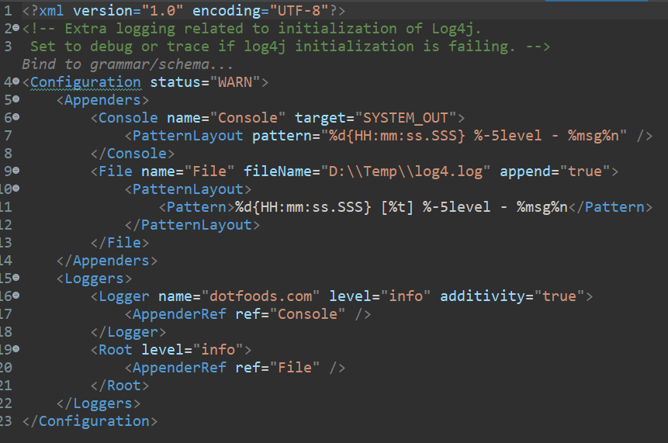

**Properties file**

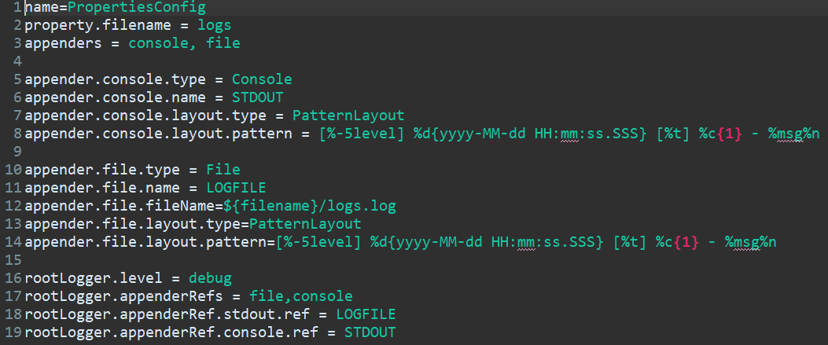

**File generation**

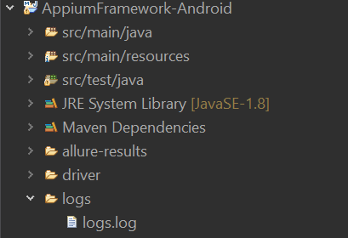

**logs.log**

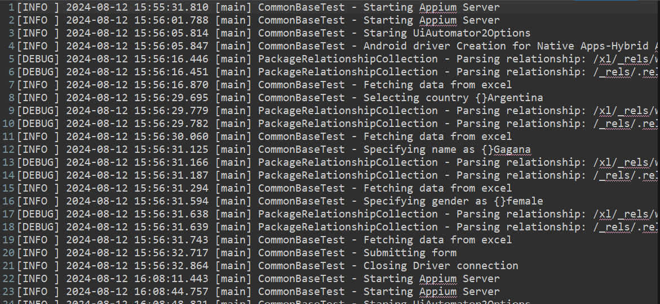

**Running Scripts Through Command Line using Maven commands**

Maven should be installed in your system with environment variable setup.

Create Profiles using maven-surefire-plugin in pom.xml (Serach for the plugin)

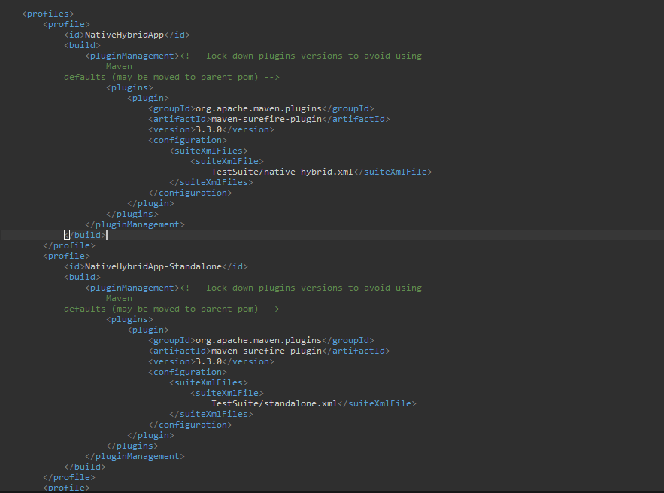

Open cmd prompt upto your framework pom.xml

Execute command -> mvn test –PNativeHybridApp

(P -> stands for profile)

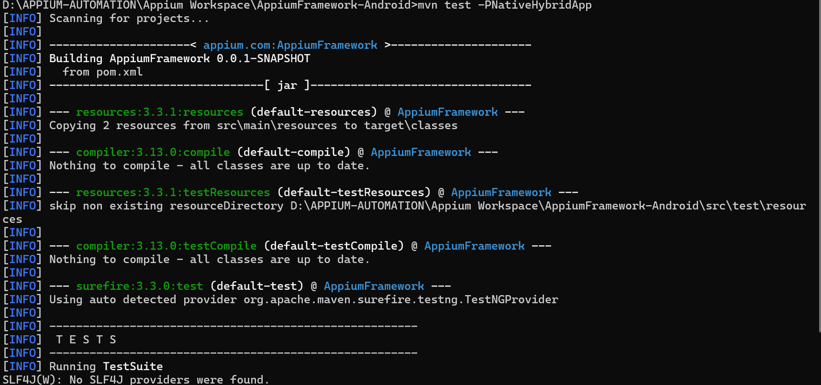

**Jenkins Setup**

* Start the Jenkins through war file
* Download War file from official website: **https://www.jenkins.io/download/**
* Open cmd prompt where the war file is present: **java –jar jenkins.war --httpPort=9090**

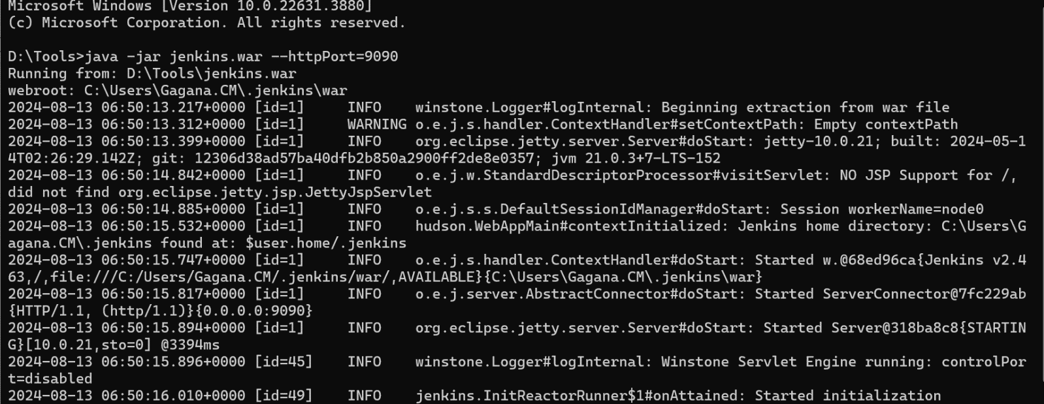

**Free Style Project**

* Jenkins Dashboard:

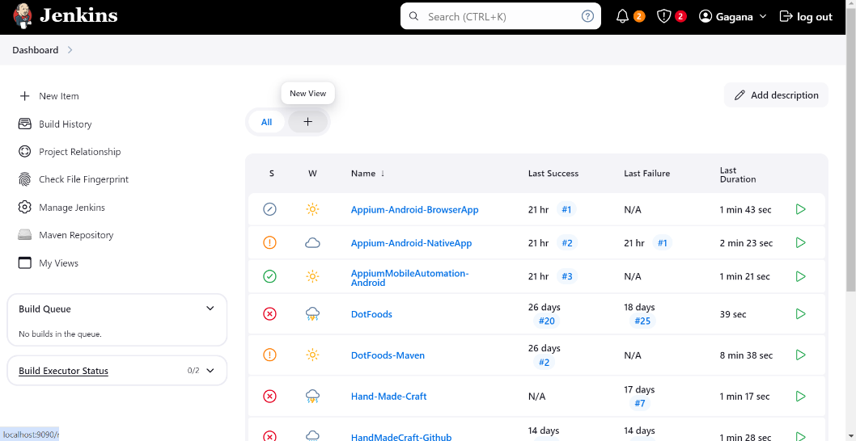

* Click on New Item > Name the project and select Free Style Project and click on Ok

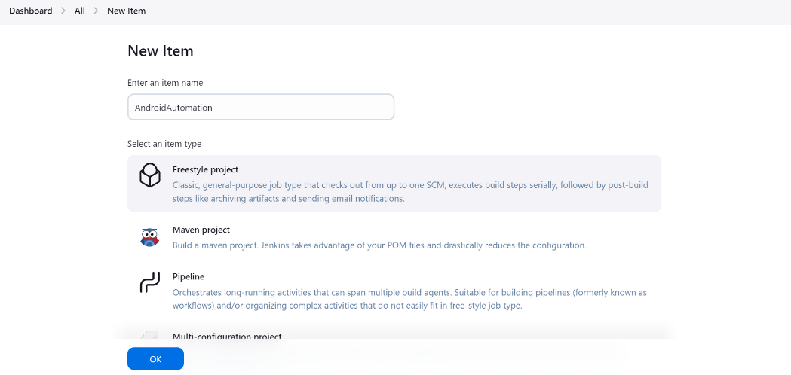

* Click on Configure and give choice parameters according to profiles you created

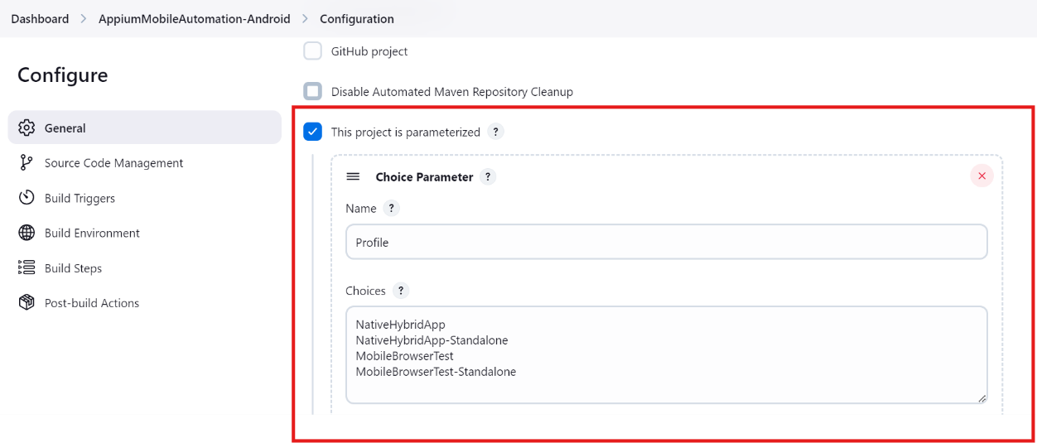

* Specify the directory of your project

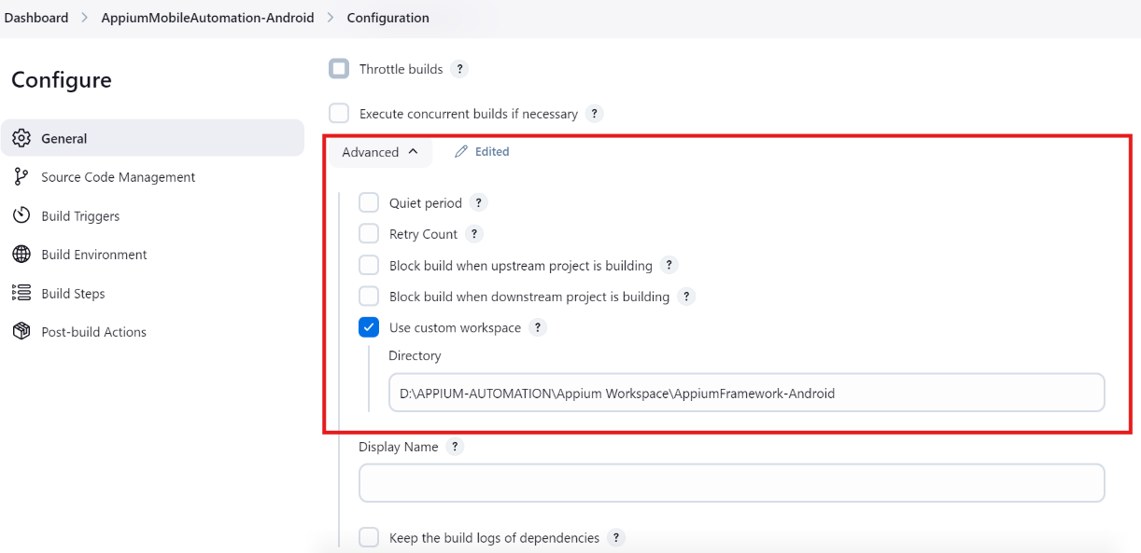

* Specify the command

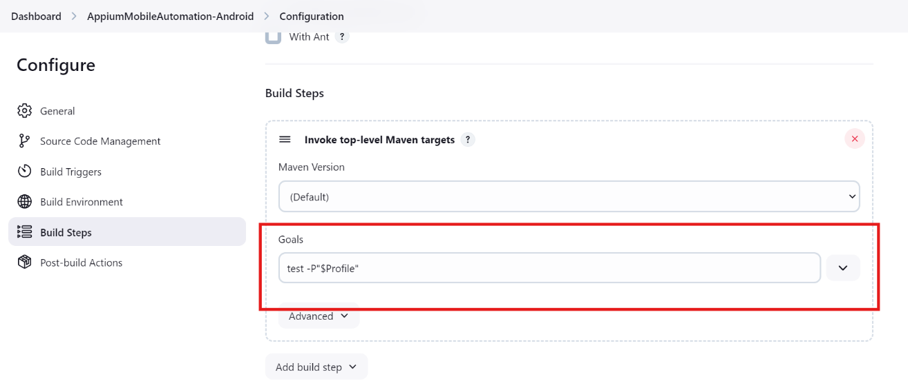

* Click on apply and save.
* Click on Build with Parameters.

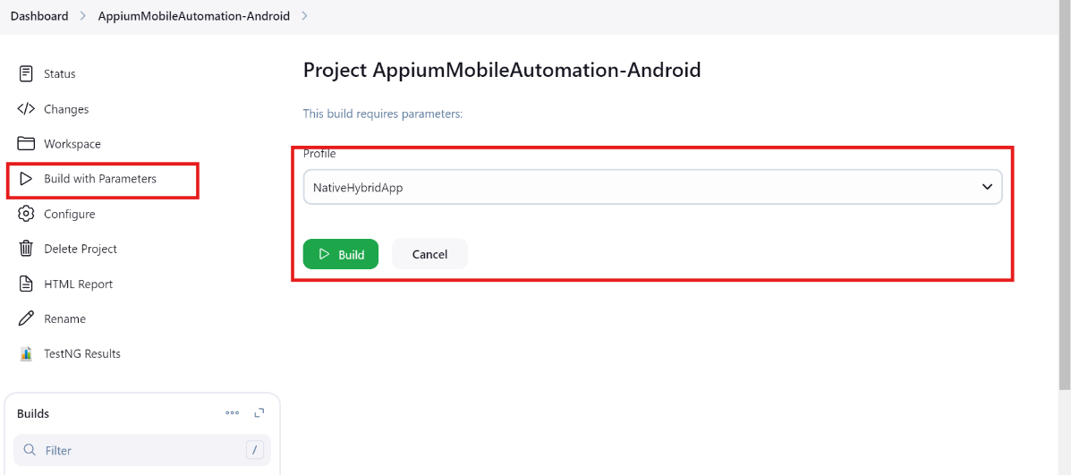

**Maven Project**

* Jenkins Dashboard:



* In the left navigation click on Manage jenkins -> Click on Plugins -> Click on Available plugins in left pane

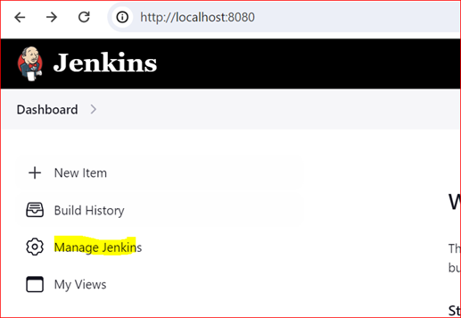

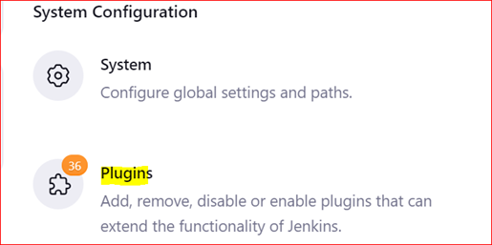

* Click on Available plugins link in left pane and enter Search keyword as Maven

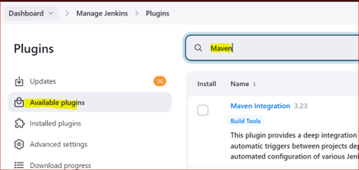

* Select the Checkbox of Maven Integration, Maven Release Plug-in, Maven Info, Maven Artifact ChoiceListProvider (Nexus), Maven Invoker, Maven Metadata Plugin for Jenkins CI server, Maven Dependency Update Trigger, Maven Repository Scheduled Cleanup, Unleash Maven and click on down arrow present beside Install button -> Click on Install after restart.

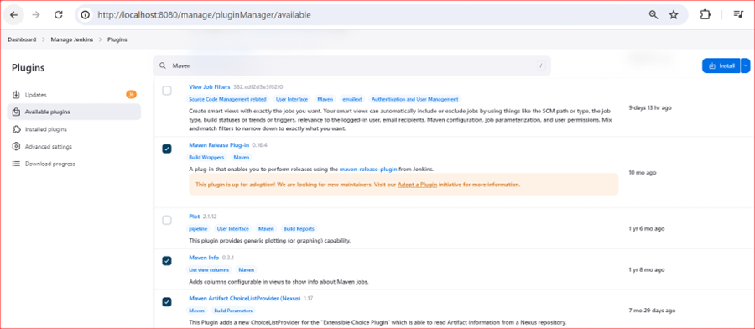

* Start the jenkins and on Jenkins dashboard
* Click on New Item > Name the project and select Maven Project and click on Ok

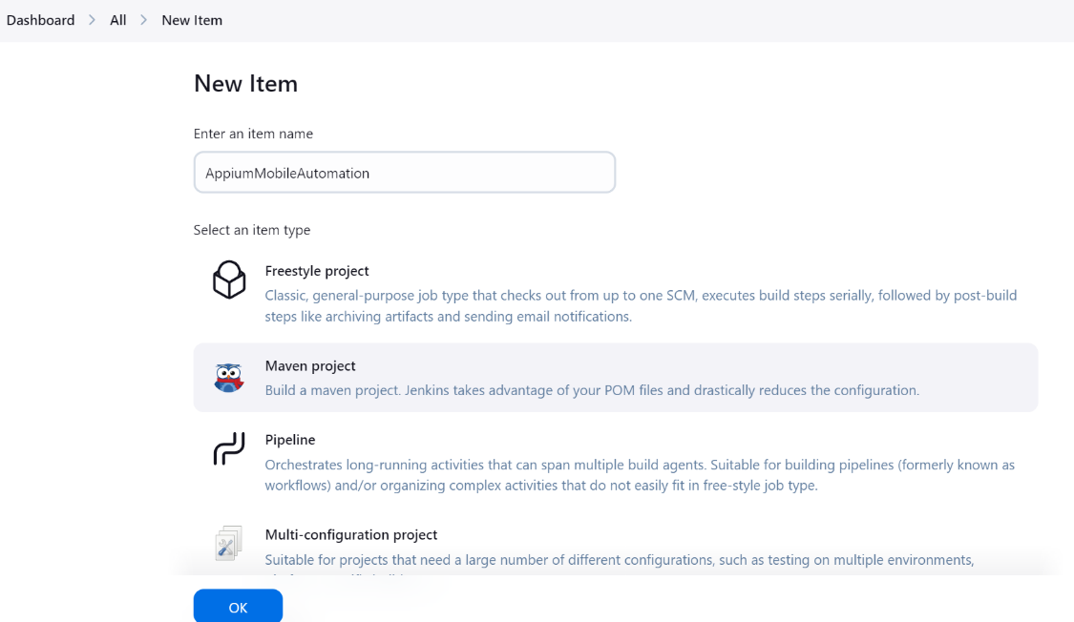

* Click on configure and specify the directory and command

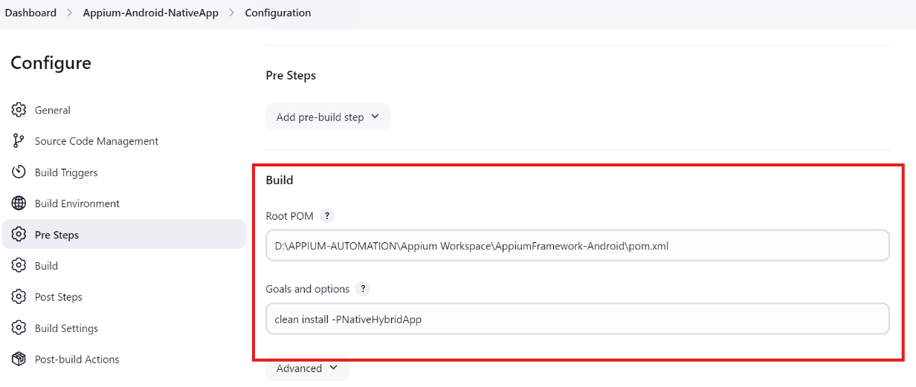

* Click on apply and save now build the project

**GitHub Integration**

* Login To your GitHub Account
* Create Repository
* Open Command Prompt where your framework is present
* Give cmd as > **git init** and verify for .git dir

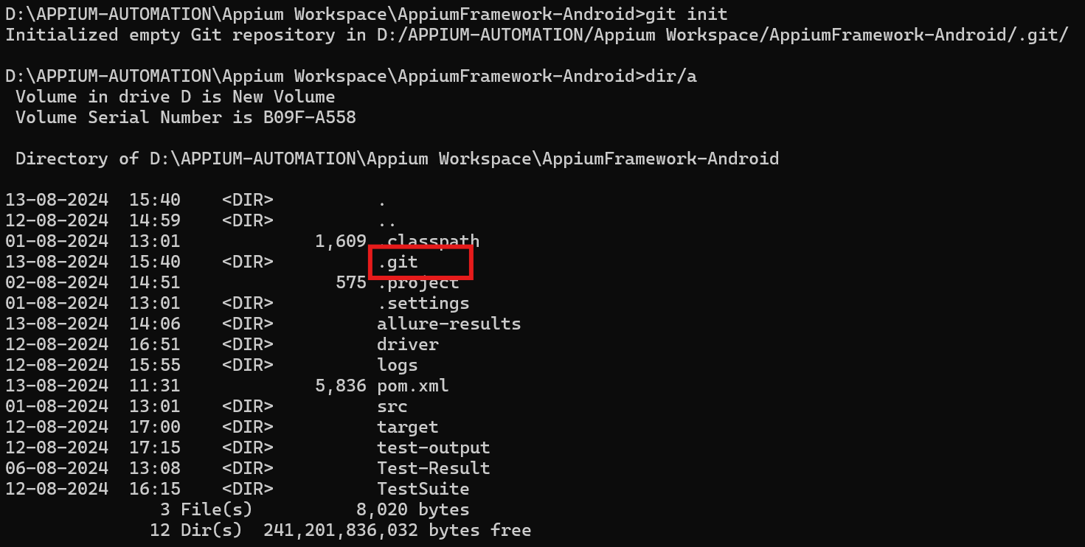

* Add Your Remote Repository and give git status as below

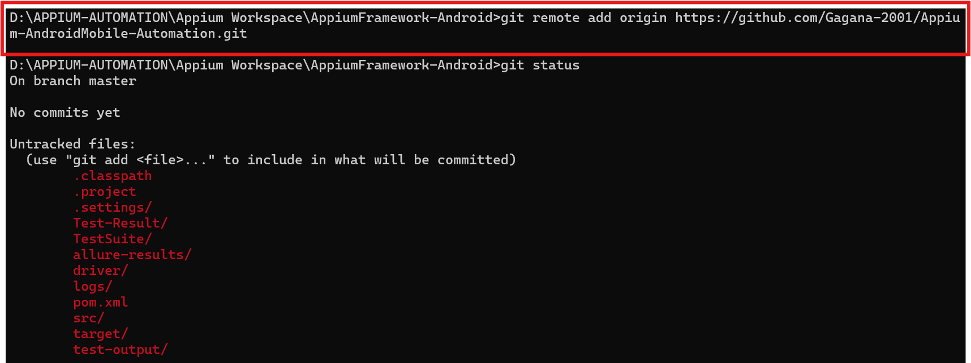

* And add all file to remote repo ,check status and commit the code by giving commands as below

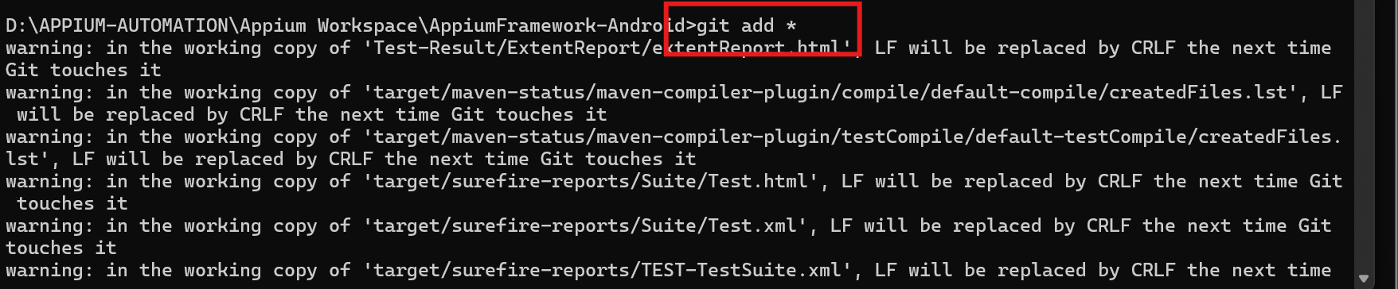

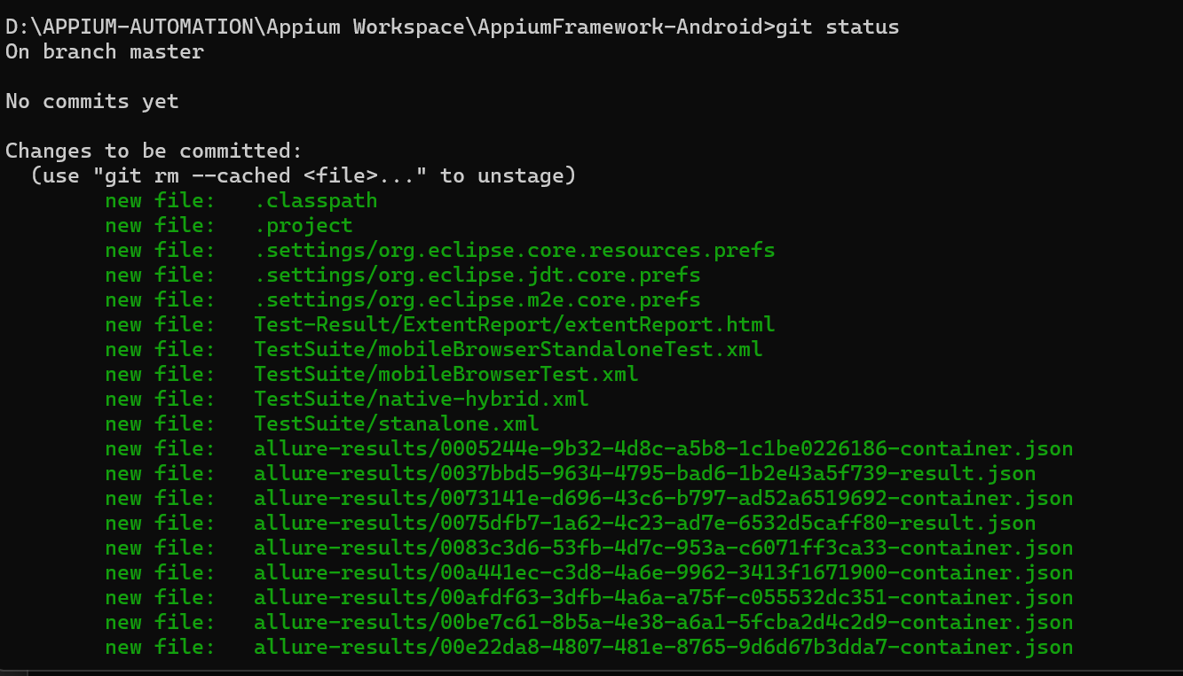

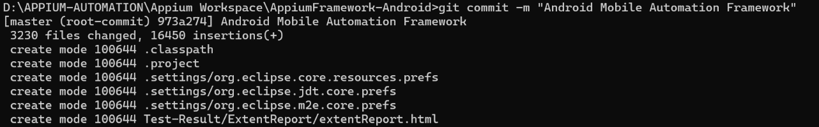

* Then Push code to branch

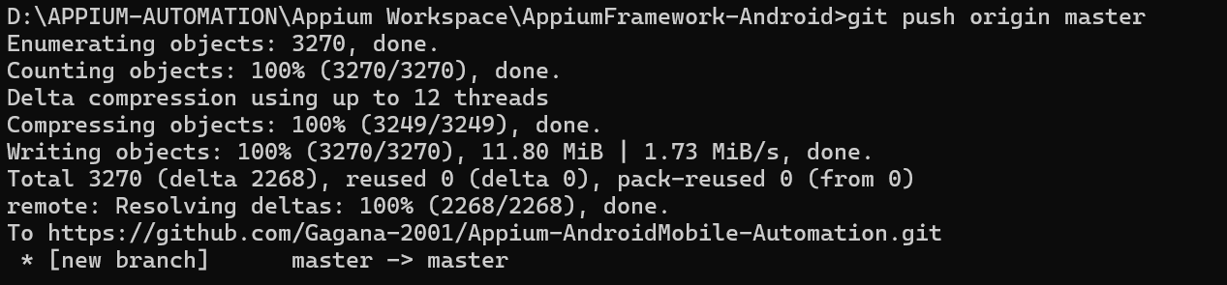

* Start The jenkins
* Create New Item, Choose Maven Project and click on Ok
* In Configuration

Select git and give repository url

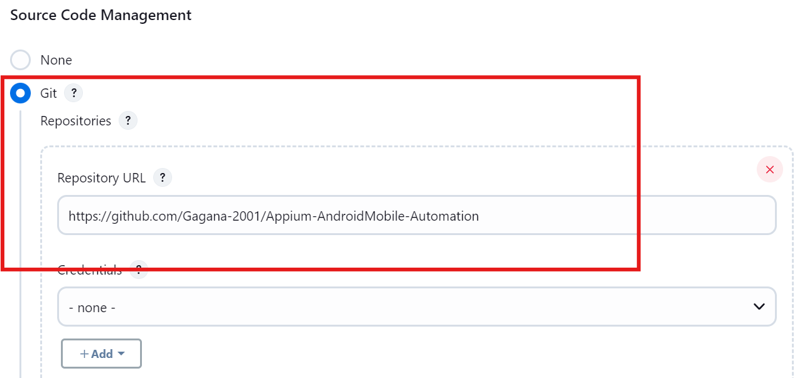

* Branch Should be master

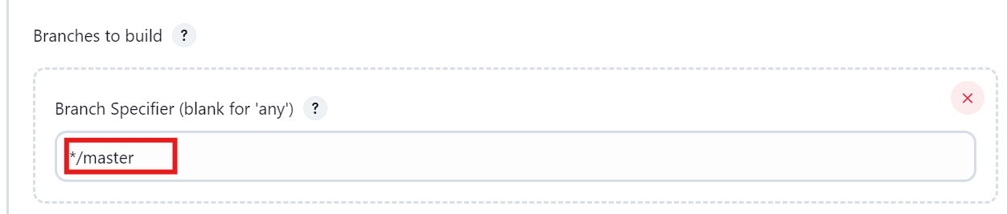

* Give Build Goals and Options

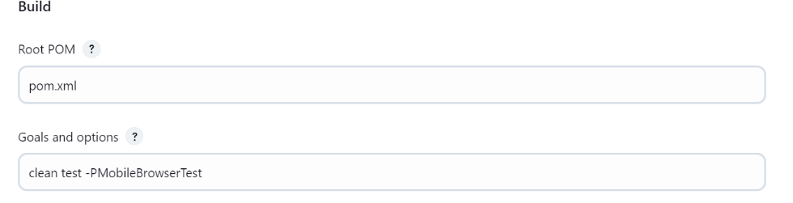

* Click on apply and save
* Click on Build

**Publishing HTML Report And TestNG Results on Jenkins**

* Start the jenkins
* Jenkins Dashboard



* In the left navigation click on Manage jenkins -> Click on Plugins -> Click on Available plugins in left pane





* Click on available puligins and search form Html Publisher and click on Install

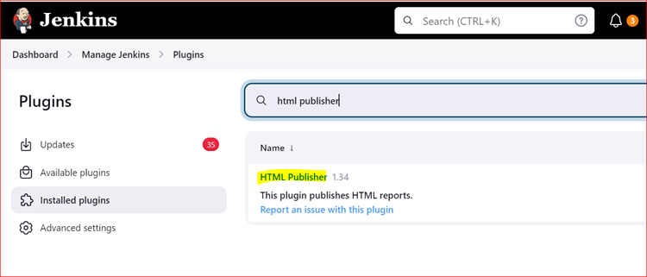

* Similarlly Search for TestNG Results pluign and install.
* Now Click on any project and click on configure on left side

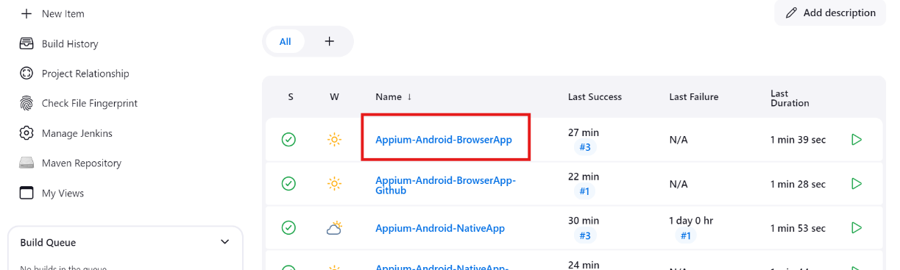

* Now Scroll upto Add Post Build Actions
* Click on Add Post Build actions
* Select Publish HTML reports and publish TestNG results

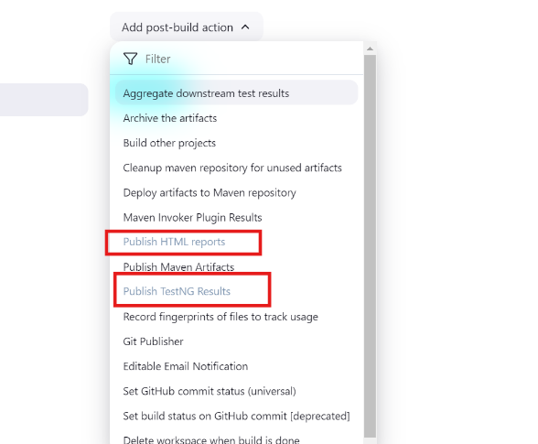

* In case of HTML Report add directory where your projects have been stored with .html file name

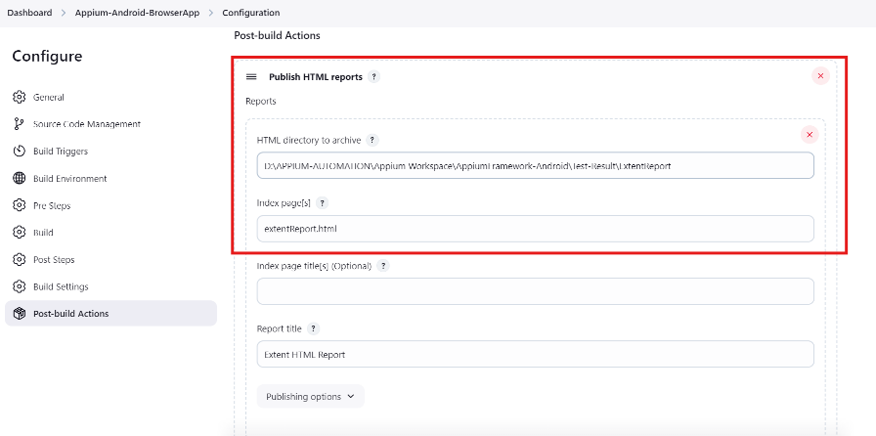

* In case of TestNg Results leave it default

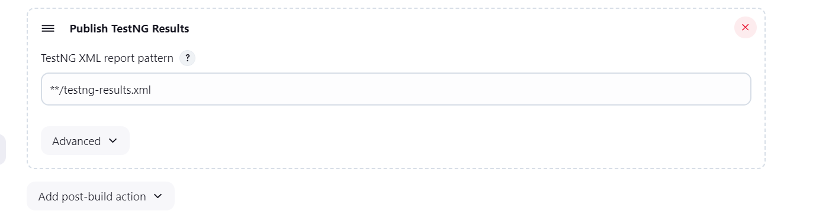

* Click on save apply and build once the build completes your able to view the reports on jenkins

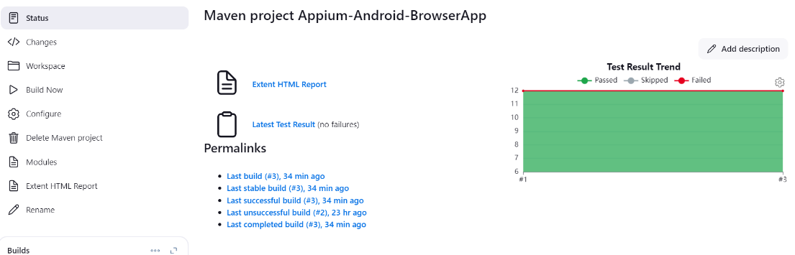

* Click on Extent Html Report you can view the Extent Report being published on Jenkins like below

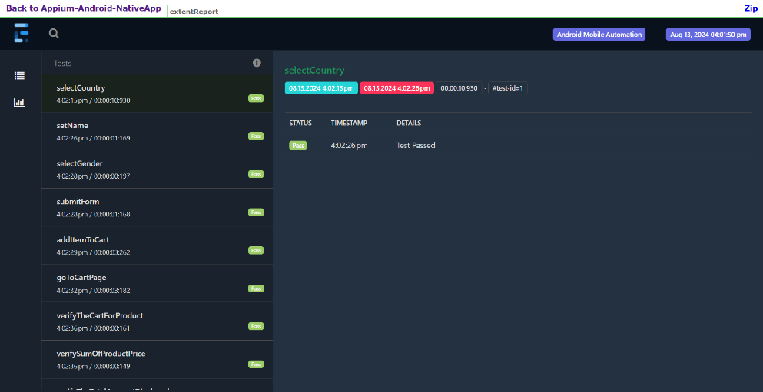

* Click on TestNG Results your able to view TestNG Results

**SMTP Configuration**

* Start the jenkins
* Jenkins Dashboard



* Then In Dashboard, Go to Manage Jenkins -> Click on System. System configuration page will be displayed where we need to to SMTP configuration.

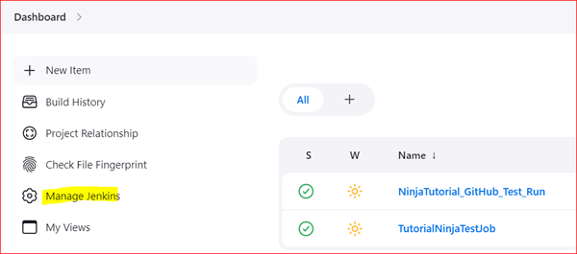

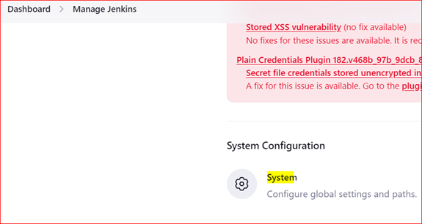

* In System page, scroll down to "Extended E-mail Notification" section

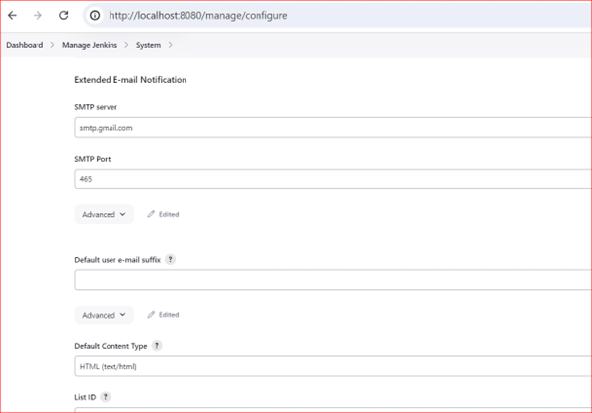

* Before doing SMTP configuration, we need to do some settings changes in Gmail manage account.

1. Login to the Gmail account which we are going to use for sending emails.

2. Go to Manage account -> Security -> 2 steps verification

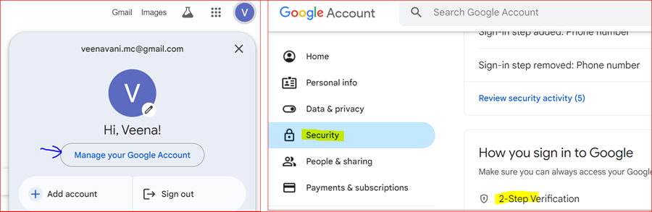

* In 2 step verification page, click on Turn on 2-step verification button, add the phone number for which code should be sent and then Save the changes

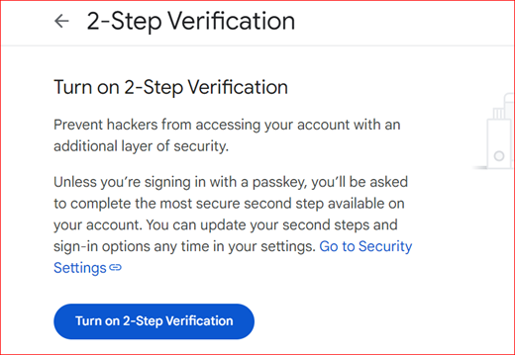

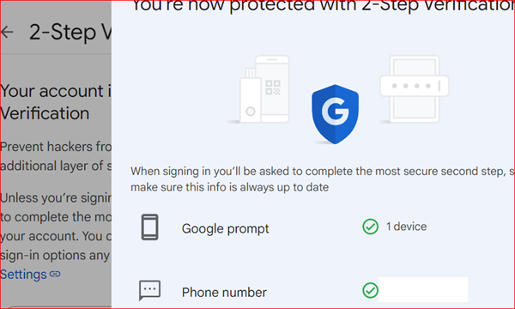

* Go to homepage of Google account and search "App password" and click on App password of security

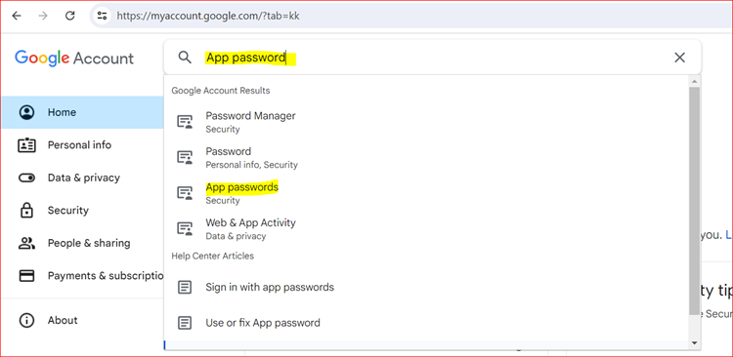

* Enter the App name as "Jenkins" and click on Create. An App password will be created. Make a note of it

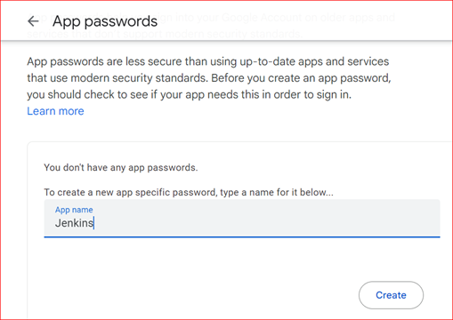

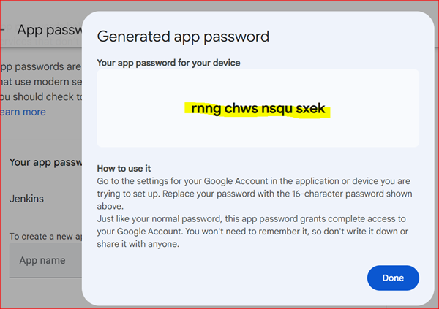

* Now, go back to System SMTP configuration page as mentioned in step 8

1. Enter SMTP server as "smtp.gmail.com" as we are using Gmail for sending emails.

2. SMTP port as 465

3. Click on Advanced.

4. Click on Add, a popup will be displayed.

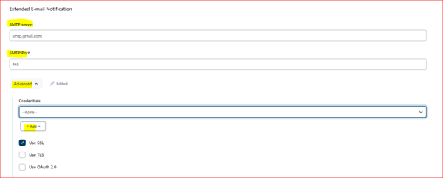

* In the popup displayed, enter the below details

1. Username: Enter the email for which 2 step authentication is done above in step 10.

2. Enter the password that you got in step 12

3. Click on Save.

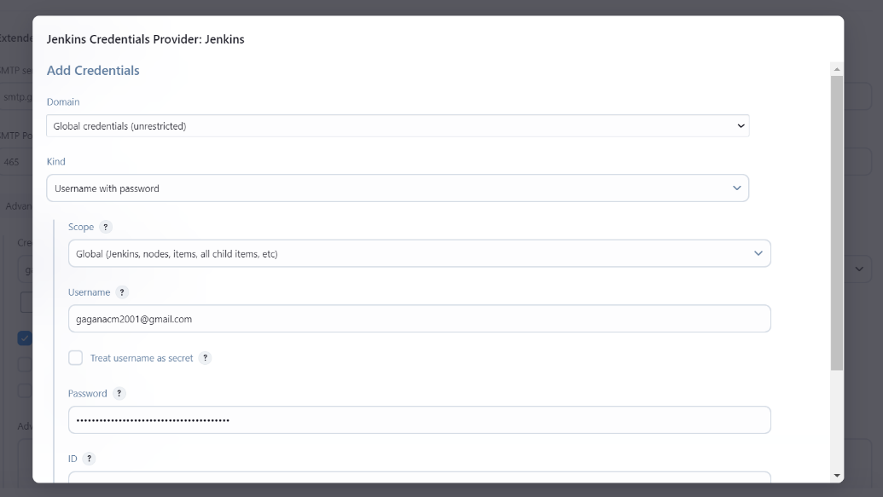

* Once the credentials are saved, click on Credentials drop down and select the credentials which we added just now in the popup window. And also select Use SSL checkbox.

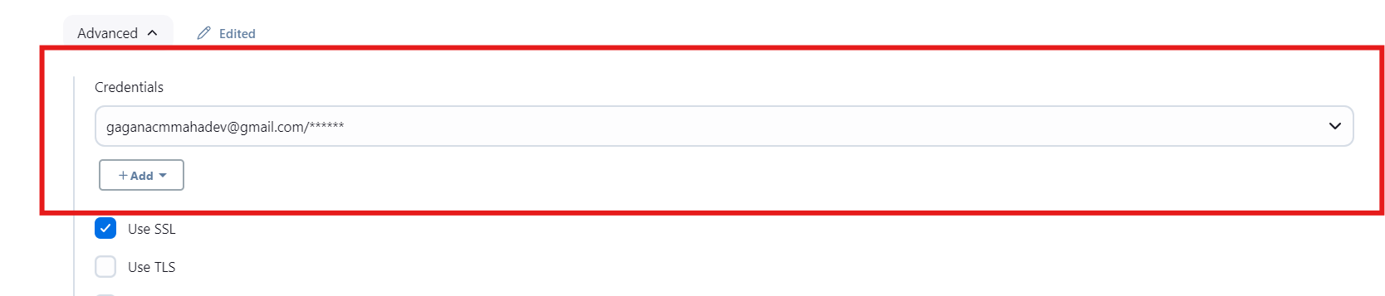

* Scroll down and select Default content type as "HTML" and enter the default recipients who needs to get the email.

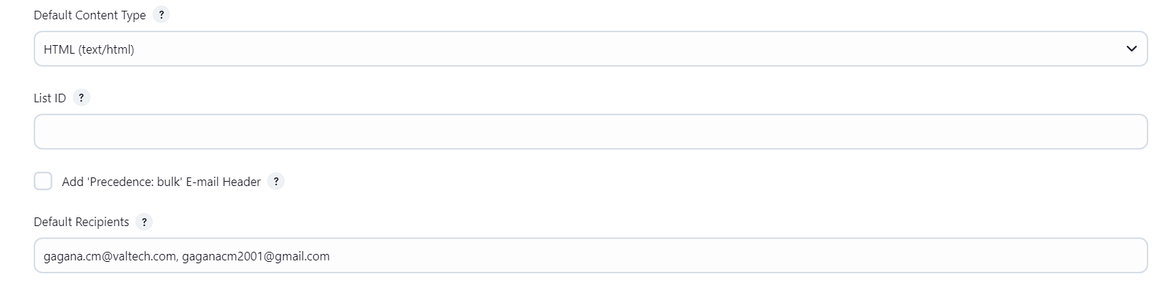

* Scroll down further and click on Default triggers. Select "Always"

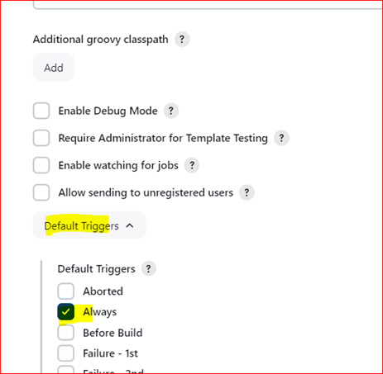

* Click on Apply and save -> Configuration will be saved

**Sending Email Notification**

* Start the jenkins
* Now go to the particular build or job that is configured. Click on Configure -> Scroll down and go to Post Build Action -> Click on Add Post Build action drop down -> Select Editable Email notification

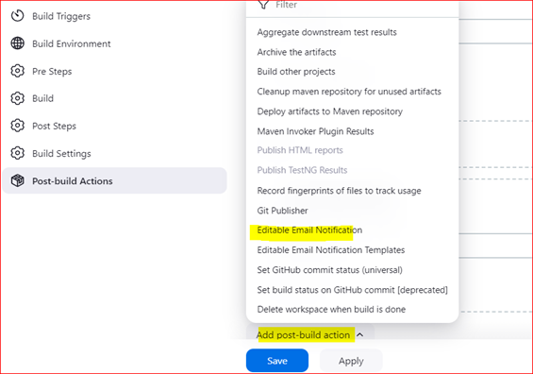

* Under Editable Email notification section, enter the details to Project name, Project recipient list, select content type as shown in screenshot.

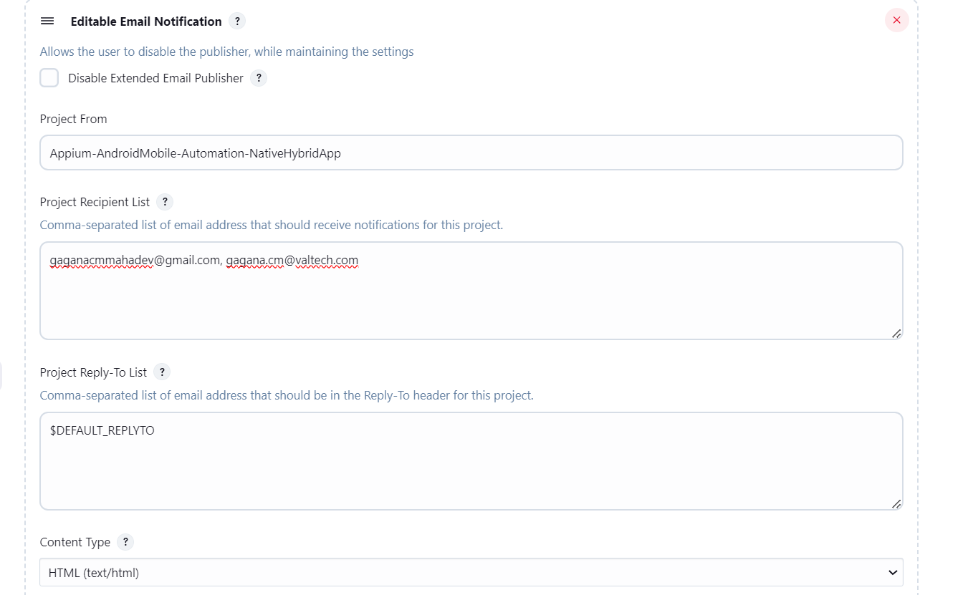

* Click on Appy and save
* Click on Build now and after completing the build, an email notification will be sent to the given email address

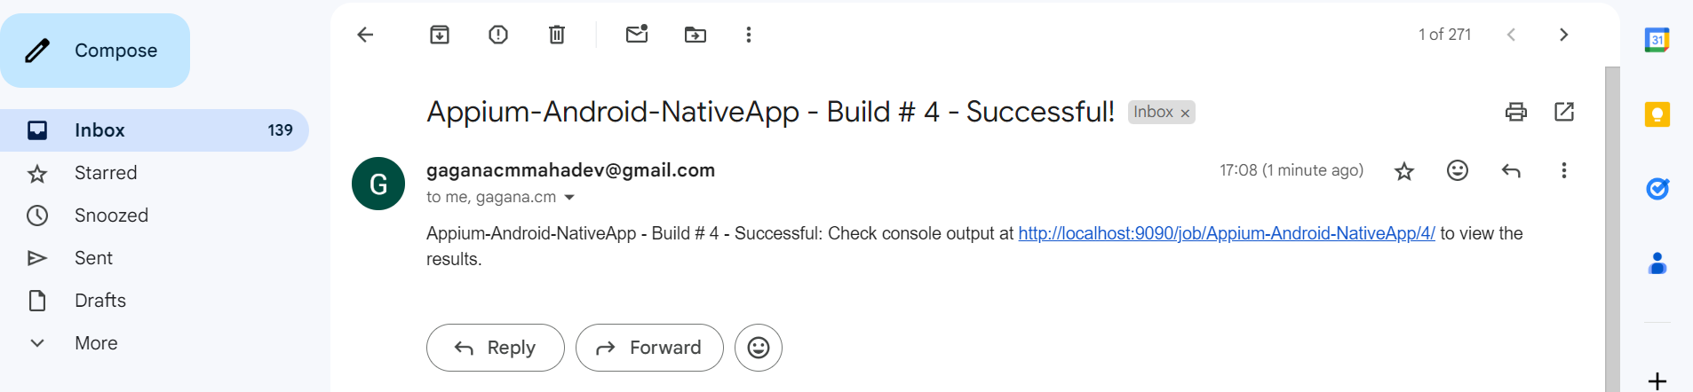

**Sending Email with Report attachment**

* Follow all the steps mentioned in Sending Email Notification
* as mentioned in Send Email Notification , Under Editable Email notification section, along with the details like Project name, Project recipient list, select content type, we need to enter the report name which we need to send in an email in Attachments field.
* The file name should be given in the format as example **/*Index.html

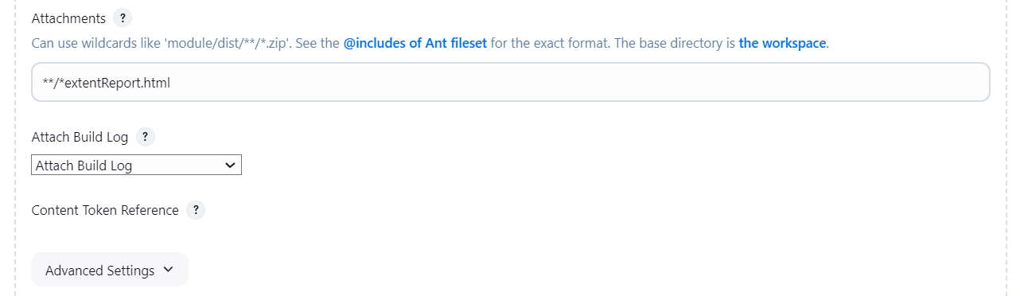

* Click on Apply and save
* Click on Build now and after completing the build, an email notification will be sent to the given email address with report attachment

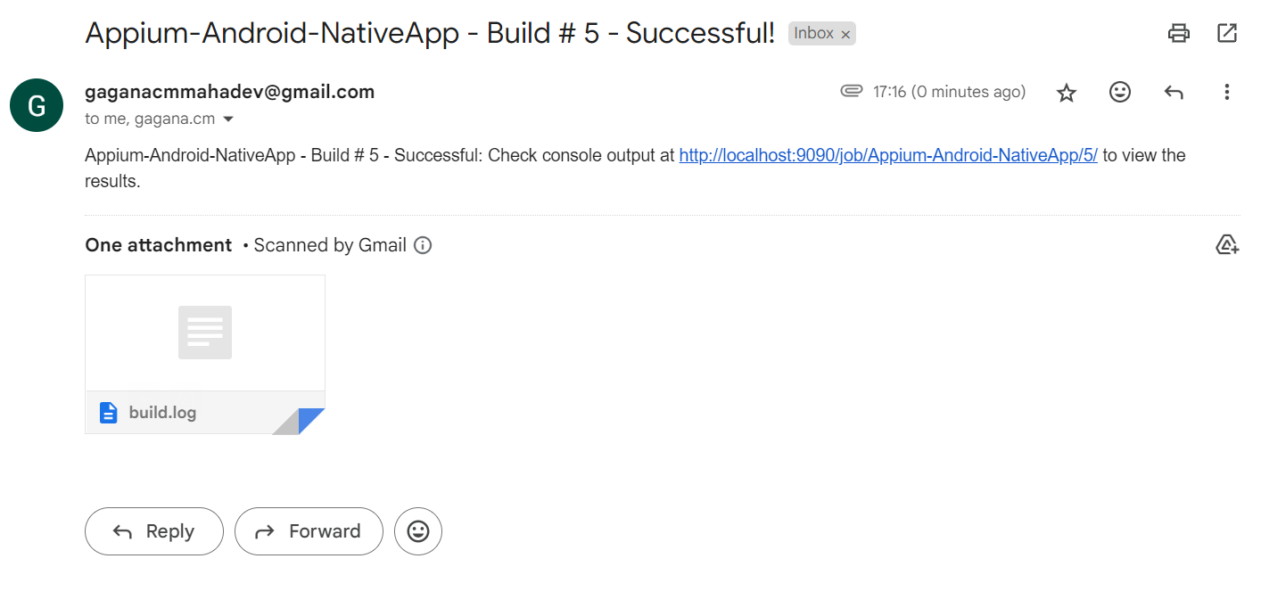

**Scheduling The Job with Build Triggers**

* Start the jenkins.
* Select the job which you want to schedule
* Click on configure
* Click on Build Triggers

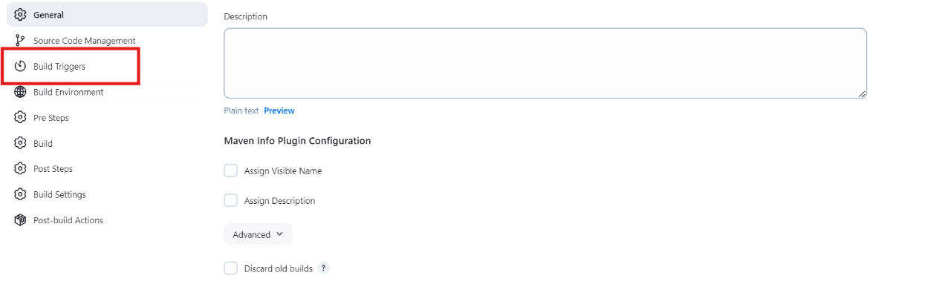

* Select Build Periodically Check box and specify the job timings as below

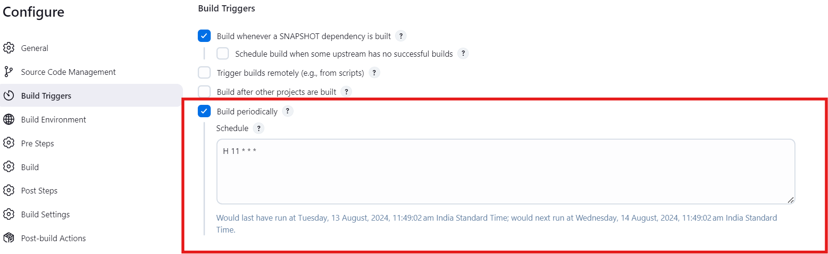

* Click on apply and save
* The build will be scheduled for the job